**Objective Questions:**

1. List the different dtypes of columns in table “ball_by_ball” (using information schema)

**Ans:**

* Below are the different data types of columns in the “ball_by_ball” table.

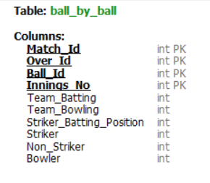

1. What is the total number of run scored in 1st season by RCB (bonus : also include the extra runs using the extra runs table)

**Ans:**  The total No of runs scored by RCB in season_1, including extra runs is **1983**

To get total runs scored from the raw data I have sql query

* I have created 3 CTE for each table
* To extract the appropriate data from the table I have joined all the CTEs with the foreign keys
* To get total runs used, union all

**Coding:**

WITH match_detail AS

(SELECT Match_Id , Team_1 , Team_2 , Toss_Winner , Toss_Decide ,

CASE WHEN Toss_Winner = 2 AND Toss_Decide = 1 THEN 2

WHEN Toss_Winner = 2 AND Toss_Decide = 2 THEN 1

WHEN Toss_Winner !=2 AND Toss_Decide = 1 THEN 1

WHEN Toss_Winner !=2 AND Toss_Decide = 2 THEN 2 END AS Innings

FROM matches

WHERE Season_Id = 1 AND (Team_1 = 2 OR Team_2 = 2))

,

Runs_from_bat AS

(SELECT SUM(bs.Runs_Scored) AS total

FROM batsman_scored bs

JOIN match_detail md

ON md.Match_Id = bs.Match_Id AND bs.Innings_No = md.Innings)

,

Runs_from_extra AS

(SELECT sum(er.Extra_Runs) total

FROM extra_runs er

JOIN match_detail md

ON er.Match_Id = md.Match_Id AND er.Innings_No = md.Innings)

SELECT SUM(runs.total) Total_runs_by_RCB_in_Season_1

FROM

(SELECT total FROM Runs_from_bat rb

UNION ALL

SELECT total FROM Runs_from_extra re) runs;

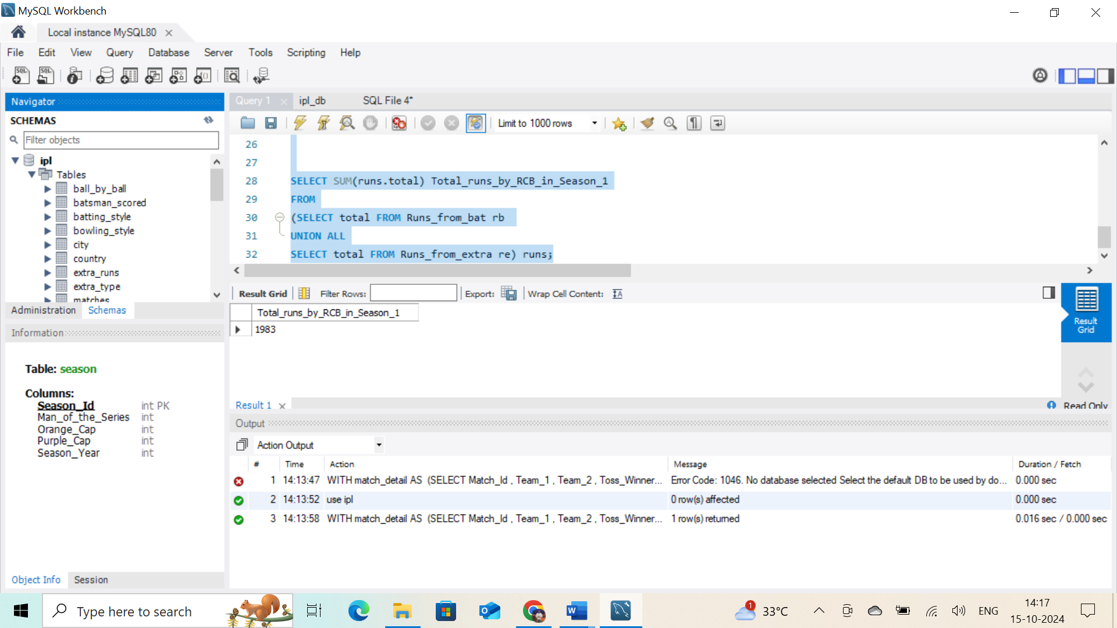

1. How many players were more than age of 25 during season 2 ?

**Ans:** There are total **194 players** above the age of 25 during season 2.

To get the players from the data I have queried

* I have used year of the DOB of players and subtracted them with the year
* Counted the player_id to get the numbers
* And applied the filter where the age is above 25

--------------------------------------------------------------------------------------------------------------

**Coding:**

WITH cte1 AS (SELECT player_id,(2009-year(dob)) AS age FROM player),

cte2 AS ( SELECT * FROM player_match)

SELECT count(distinct cte1.player_id) AS player_count FROM cte1

JOIN cte2

ON cte1.player_id=cte2.player_id

WHERE age>25;

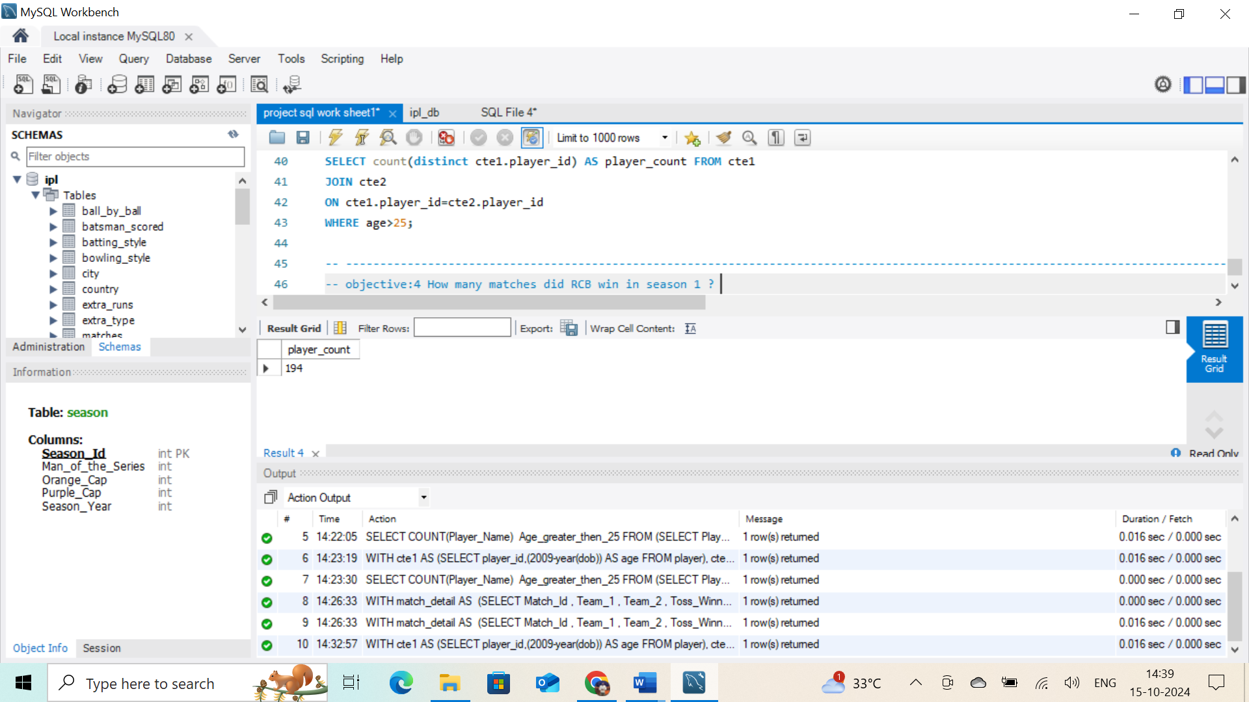

1. How many matches did RCB win in season 1 ?

**Ans:** There are total no of **4 matches** which where won by RCB during season 1

To get the data

* Selected data from matches

Set the funcation where match won by team and the season id

-------------------------------------------------------------------------------------------------------------------

**Coding:**

SELECT Count(Match_Winner) Matches_win_by_RCB_in_Season1

FROM matches

WHERE Season_Id = 1 AND Match_Winner = 2;

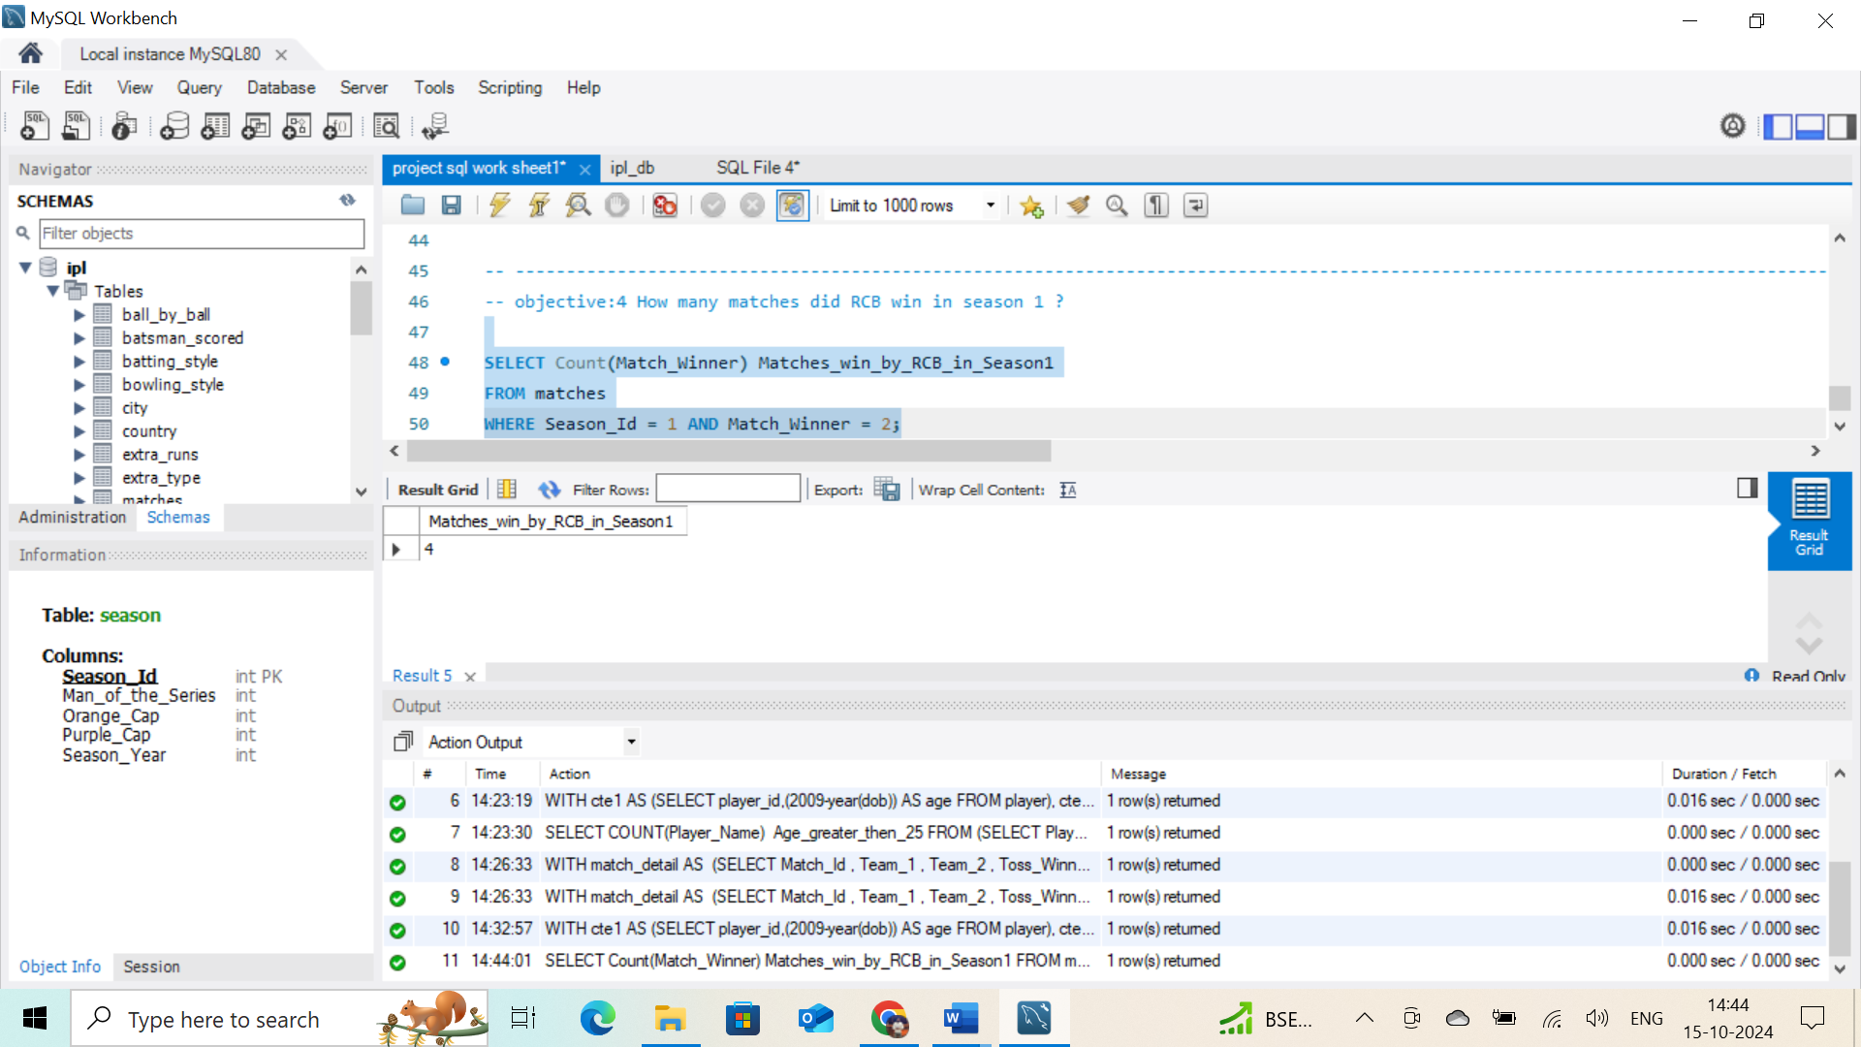

1. List top 10 players according to their strike rate in last 4 seasons

**Ans:**

* To get the details of top 10 player with high strike rate I have used CTE table
* I have joined different table such as ball_to_ball,player, and batsman_scored
* To find out the strike rate I used the formula **sum(bs.Runs_Scored)/count(bb.Ball_Id) * 100**
* This provided with the strike rate and to limit to last 4 season I have used limit function
* After creating CTE table with above tables I have joined all and find last 4seasons using match_id with matches table with a subquery.
* From main query, I taken required results joining with player table to get player names.

-------------------------------------------------------------------------------------------------------------------

**Coding:**

with total_details as

( select bb.

Striker,count(bb.Ball_Id) balls, sum(bs.Runs_Scored) runs,

sum(bs.Runs_Scored)/count(bb.Ball_Id) * 100 strike_Rate

from ball_by_ball bb

join batsman_scored bs on bb.Match_Id = bs.Match_Id and bb.Over_Id = bs.Over_Id and bb.Ball_Id = bs.Ball_Id

join player p on bb.Striker = p.Player_Id

where bb.Match_Id in (select m.Match_Id from matches m

where m.Season_Id in(6,7,8,9))

group by bb.Striker)

select p.Player_Name, ds.Striker,ds.runs,ds.balls,ds.strike_Rate

from total_details ds

join player p on p.Player_Id = ds.Striker

where ds.balls > 100

order by ds.strike_Rate desc

limit 10;

**Top 10 player according to the strike rate in last 4 season are:**

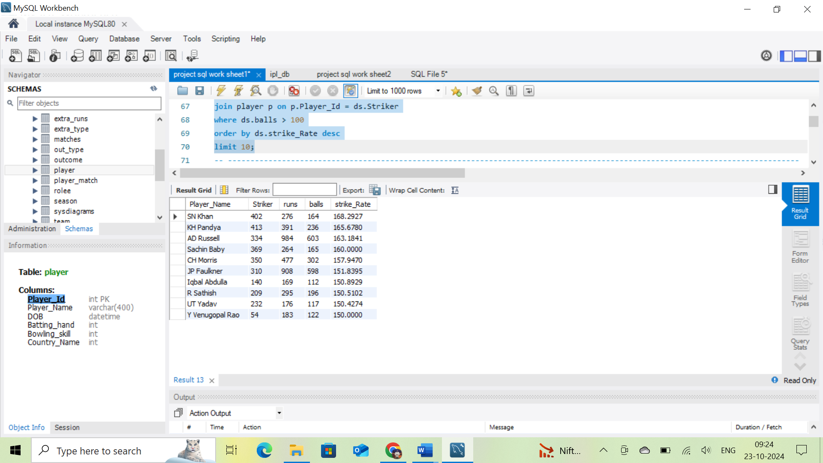

1. What is the average runs scored by each batsman considering all the seasons?

Ans: To get the average runs scored by each batsman considering all seasons.

* I used CTE table to find out the average through main table.
* I used 3tables “ball_by_ball”,”player”,”batsman_scored” for required columns, I joined all 3 tables
* Them from main table, I got the required result by ordering avg-batting

-------------------------------------------------------------------------------------------------------------------

**Coding:**

with total_details as

(select p.Player_Name, count(distinct bs.Match_Id) match_played , sum(bs.Runs_Scored) runs,

sum(bs.Runs_Scored)/count(distinct bs.Match_Id) avg_batting

from ball_by_ball bb

join batsman_scored bs on bb.Match_Id = bs.Match_Id and bb.Over_Id =bs.Over_Id and bb.Ball_Id = bs.Ball_Id

join player p on bb.Striker = p.Player_Id

group by p.Player_Name)

select td.Player_Name,td.match_played,td.runs,td.avg_batting

from total_details td

order by td.avg_batting desc;

**sample data as output:** considering all seasons the below table gives average runs scored

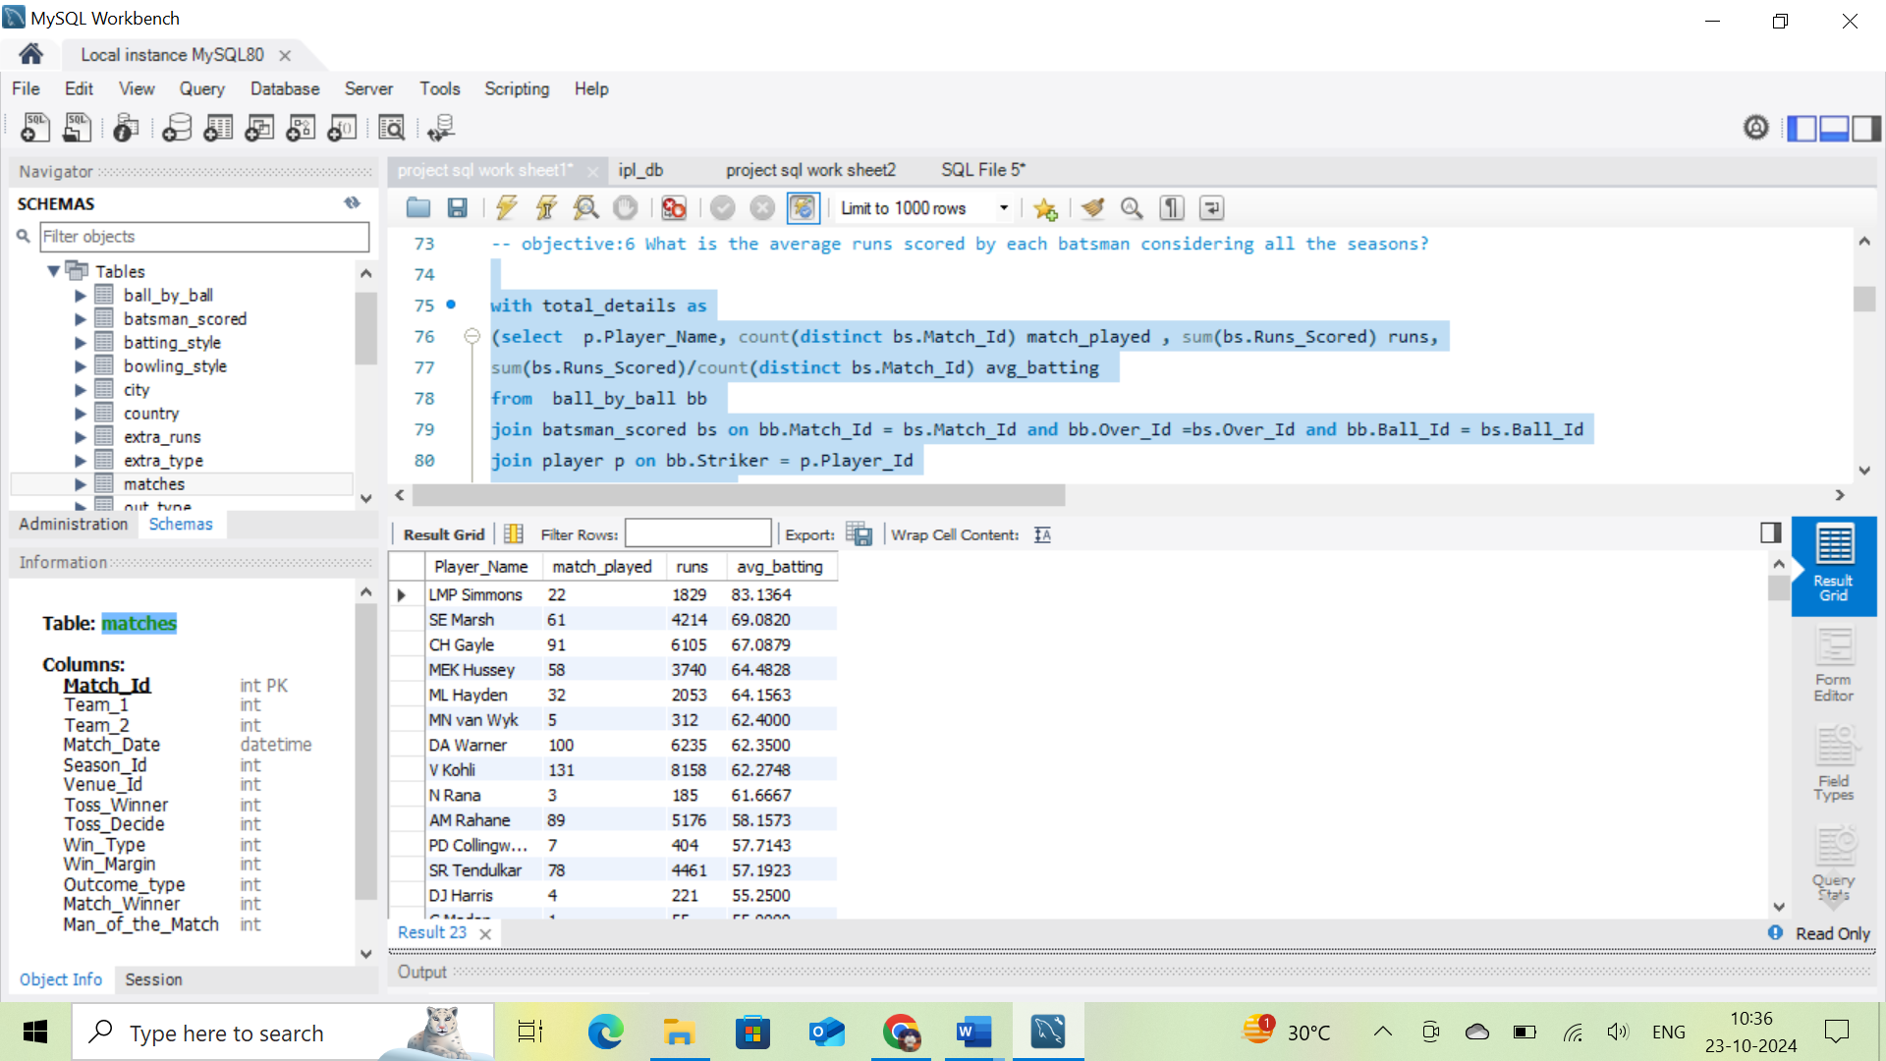

1. What are the average wickets taken by each bowler considering all the seasons?

**Ans:** To calculate the average wicket taken by each bowler considering all season

* I used 2 CTE’s named “match_by_bowler” and “average_taken_wickets” as main tables.
* For creating CTE’s, I used tables from given data and joined with each other.
* Used tables like “ball_by_ball”,” batsman_scored”,” wicket_taken” for creating CTE tables.
* From both CTE’s, I joined the tables for required output. Used average for wickets/match_played to get wickets_average.

-------------------------------------------------------------------------------------------------------------------

**Coding:**

with match_by_bowler as (

select bb.Bowler, count( distinct bb.Match_Id) match_played

from ball_by_ball bb

join batsman_scored bs on bb.Match_Id = bs.Match_Id and bb.Over_Id= bs.Over_Id and bb.Ball_Id = bs.Ball_Id

and bb.Innings_No = bs.Innings_No

group by bb.Bowler),

average_taken_wickets as (

select bb.Bowler, count(wt.Kind_Out) wickets

from ball_by_ball bb

join wicket_taken wt on bb.Match_Id = wt.Match_Id and bb.Over_Id = wt.Over_Id and bb.Ball_Id = wt.Ball_Id

and bb.Innings_No = wt.Innings_No

group by bb.Bowler)

select mbb.Bowler,p.Player_Name,aw.wickets,mbb.match_played,aw.wickets/mbb.match_played wickets_average

from match_by_bowler mbb

join average_taken_wickets aw on mbb.Bowler = aw.Bowler

join player p on p.Player_Id = mbb.Bowler

order by aw.wickets desc;

**sample data as output:**

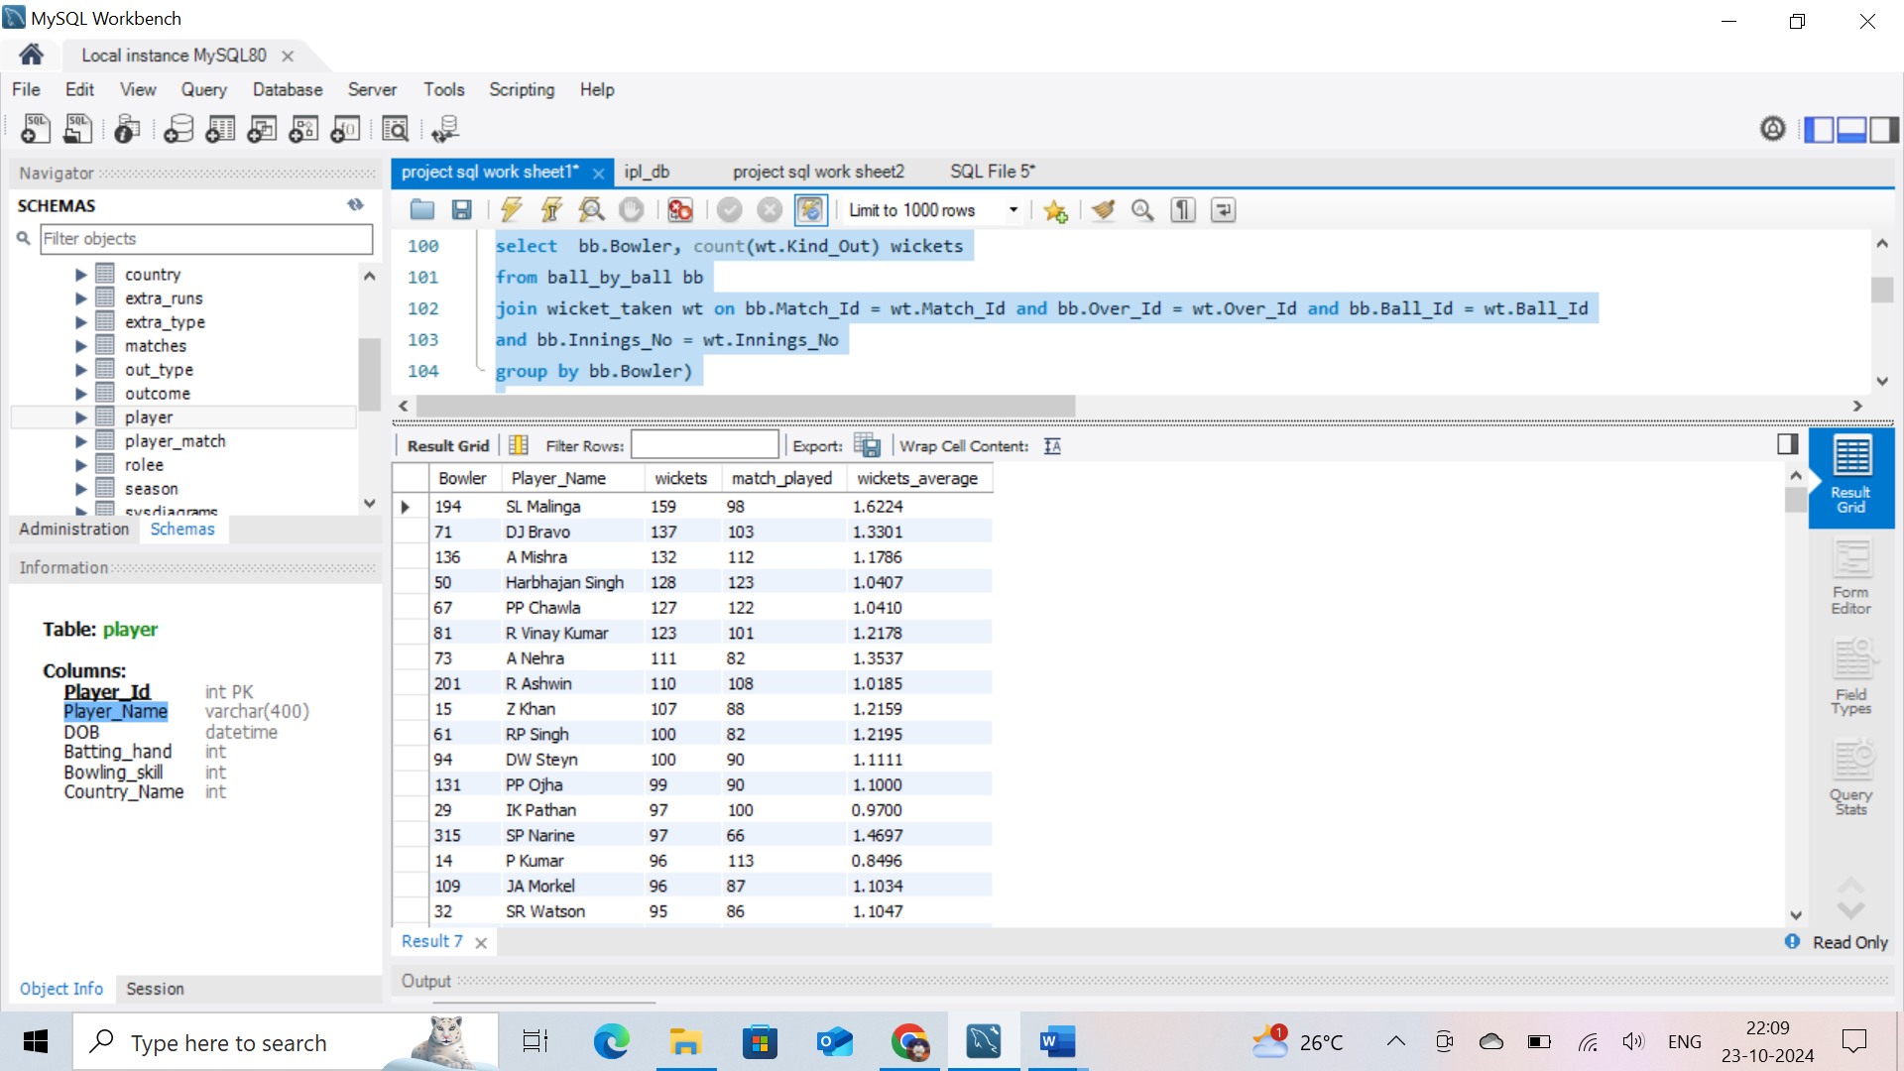

1. List all the players who have average runs scored greater than overall average and who have taken wickets greater than overall average

**Ans:** To get the average runs scored greater than overall average and average wicket greater than overall average from the data we used.

1. **Firstly,I solved average runs scored greater than overall average**

* I used CTE table to find out the average through main table.
* I used 3tables “ball_by_ball”,”player”,”batsman_scored” for required columns, I joined all 3 tables
* Them from main table, I got the required result by ordering avg-batting
* By using where clause ,I filtered. average runs scored greater than overall average

**2) Secondly, I solved average wickets taken greater than overall average**

* I used 2 CTE’s named “match_by_bowler” and “average_taken_wickets” as main tables.
* For creating CTE’s, I used tables from given data and joined with each other.
* Used tables like “ball_by_ball”,” batsman_scored”,” wicket_taken” for creating CTE tables.
* From both CTE’s, I joined the tables for required output. Used average for wickets/match_played to get wickets_average.
* By using where clause ,I filtered. average wickets taken greater than overall average

--------------------------------------------------------------------------------------------------------------------------

Coding:

**-- i) /*average runs scored greater than overall average */:**

with total_details as (

select p.Player_Name,count(distinct bs.Match_Id) match_played, sum(bs.Runs_Scored) runs,

sum(bs.Runs_Scored)/count(distinct bs.Match_Id) avg_runs_scored

from ball_by_ball bb

join batsman_scored bs

on bb.Match_Id = bs.Match_Id and bb.Over_Id= bs.Over_Id and bb.Ball_Id = bs.Ball_Id

join player p

on p.Player_Id = bb.Striker

group by p.Player_Name)

select td.Player_Name,td.match_played,td.runs,td.avg_runs_scored batting_average

from total_details td

where td.avg_runs_scored > ( select sum(td.runs)/sum(td.match_played) overall_batting_avg

from total_details td)

order by td.avg_runs_scored desc;

**sample data as output:**

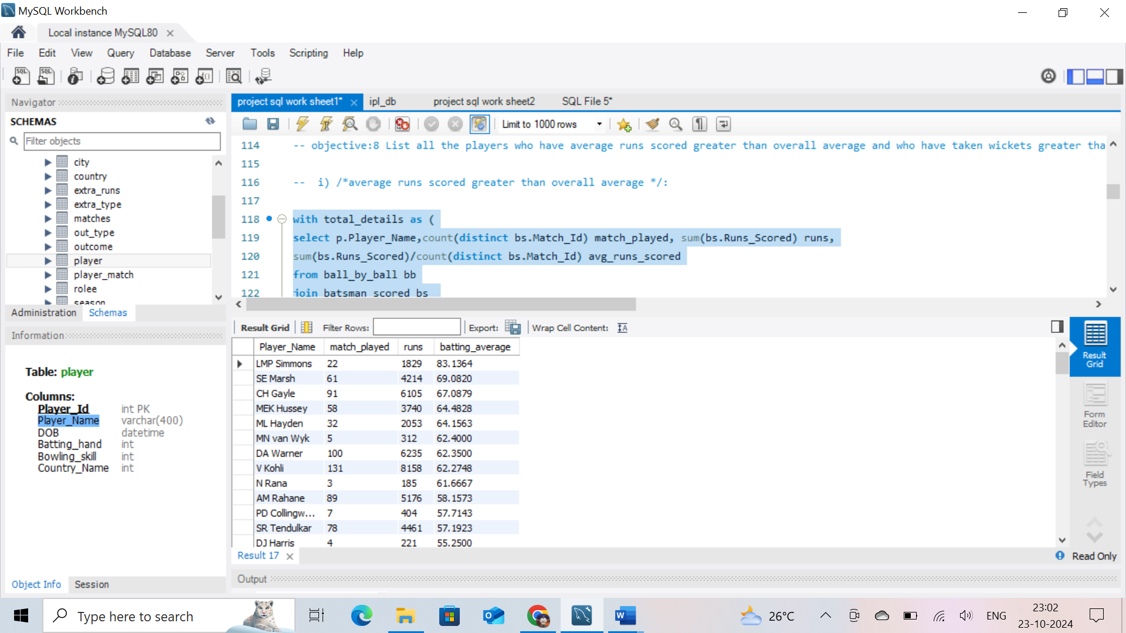

**-- ii) /*average wickets taken greater than overall average */:**

with match_by_bowler as (

select bb.Bowler, count( distinct bb.Match_Id) match_played

from ball_by_ball bb

join batsman_scored bs on bb.Match_Id = bs.Match_Id and bb.Over_Id= bs.Over_Id and bb.Ball_Id = bs.Ball_Id

and bb.Innings_No = bs.Innings_No

group by bb.Bowler),

average_taken_wickets as (

select bb.Bowler, count(wt.Kind_Out) wickets

from ball_by_ball bb

join wicket_taken wt on bb.Match_Id = wt.Match_Id and bb.Over_Id = wt.Over_Id and bb.Ball_Id = wt.Ball_Id

and bb.Innings_No = wt.Innings_No

group by bb.Bowler)

select mbb.Bowler, p.Player_Name,mbb.match_played,aw.wickets,aw.wickets/mbb.match_played as avg_wickets_taken

from match_by_bowler mbb

join average_taken_wickets aw on mbb.Bowler = aw.Bowler

join player p on p.Player_Id = mbb.Bowler

where aw.wickets/mbb.match_played > (select sum(aw.wickets)/sum(mbb.match_played) as overall_average

from match_by_bowler mbb

join average_taken_wickets aw

on mbb.Bowler = aw.Bowler

join player p

on p.Player_Id = mbb.Bowler

order by aw.wickets desc)

order by aw.wickets desc;

**sample data as output:**

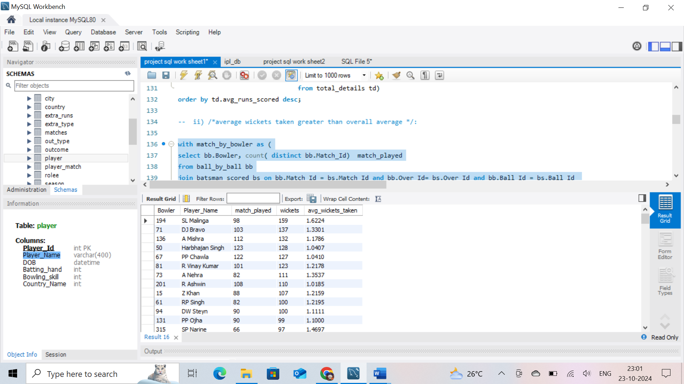

1. Create a table rcb_record table that shows wins and losses of RCB in an individual venue.

**Ans:** To get the wins and losses data of RCB in an individual venue.

* I used venue, matches tables and join them, for required columns in one table.
* I use case statement for finding matches_won,matches_loss,
* By using where clause, I filter the team_2

---------------------------------------------------------------------------------------------------------------

**Coding:**

SELECT

v.Venue_Name,

COUNT(DISTINCT m.Match_Id) matches_played,

COUNT(CASE

WHEN m.Match_Winner = 2 THEN 1

ELSE NULL

END) AS matches_won,

COUNT(CASE

WHEN m.Match_Winner != 2 THEN 1

ELSE NULL

END) AS matches_loss

FROM

venue v

JOIN

matches m ON v.Venue_Id = m.Venue_Id

WHERE

m.team_1 = 2 OR m.team_2 = 2

GROUP BY v.Venue_Name

ORDER BY matches_won DESC;

**sample data as output:**

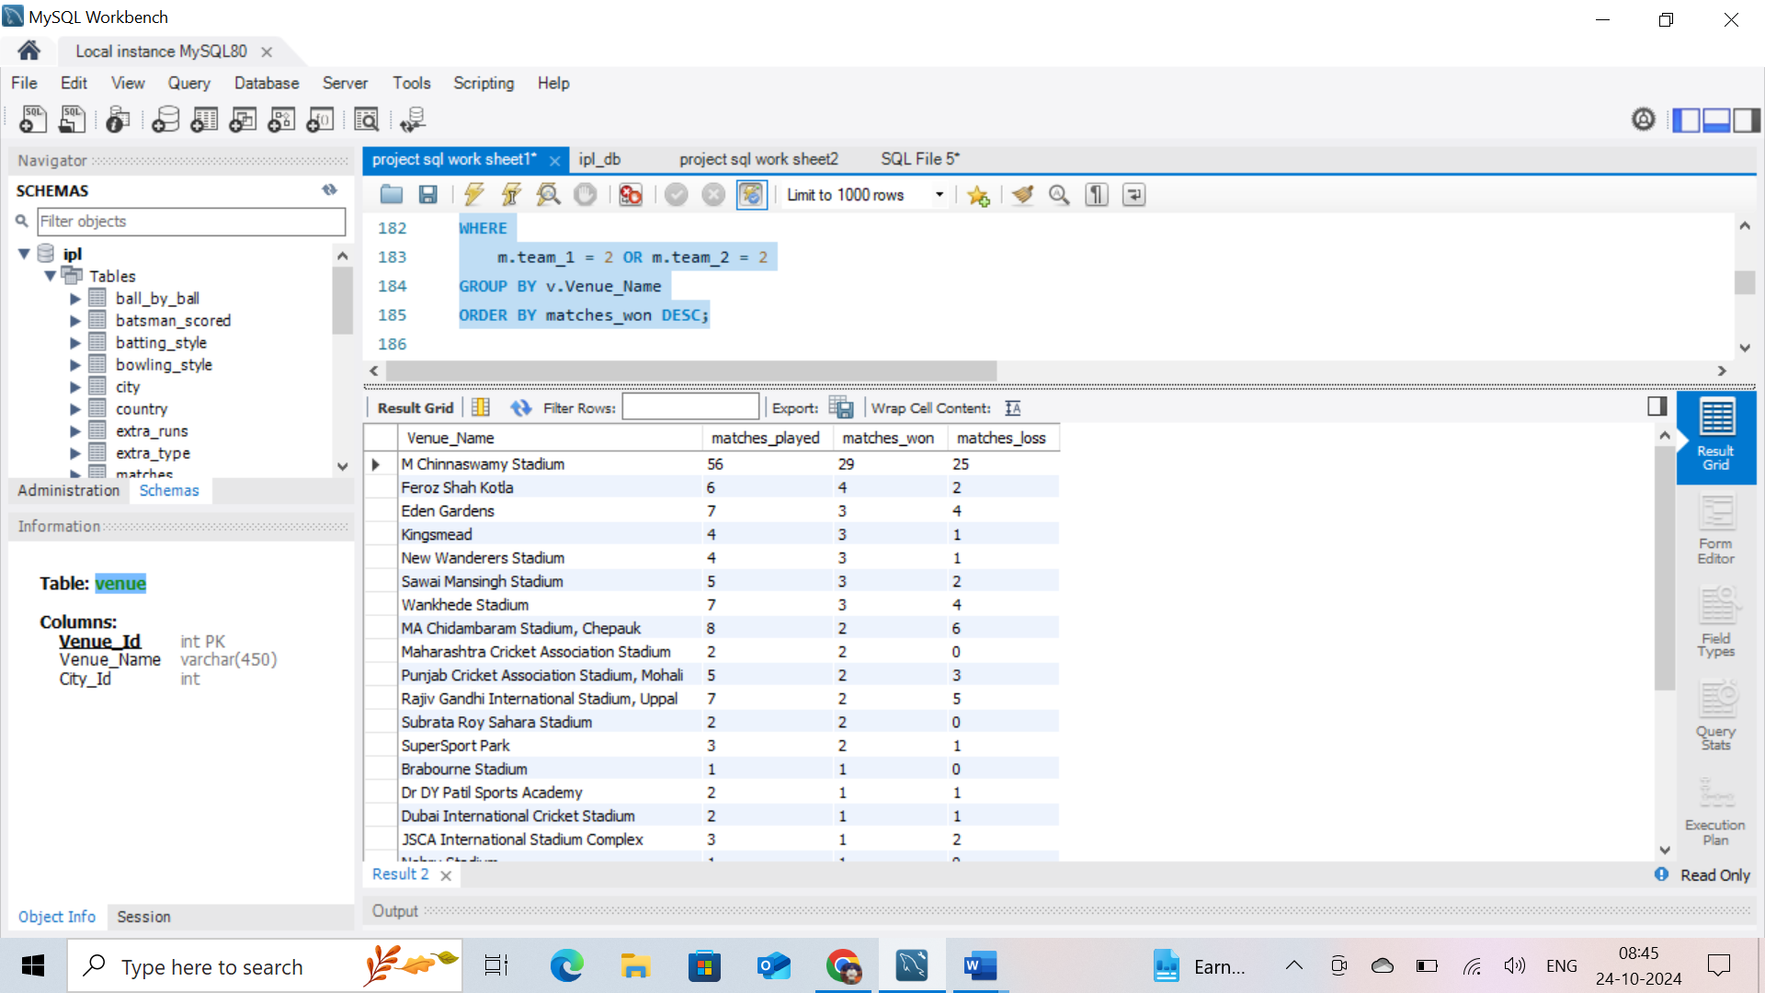

1. What is the impact of bowling style on wickets taken

**Ans:** To get the impact of bowling style on the number of wicket_taken

* I used tables like ‘’ bowling_style’’,” player “,”ball_by_ball”,” wicket_taken”, to join the tables with primary and foreign keys to get one table all required data.
* Used count to find wickets_taken,and order by descending order I got the result

--------------------------------------------------------------------------------------------------------------------------

**Coding:**

SELECT

bs.Bowling_skill, COUNT(wt.Kind_Out) wickets_taken

FROM

bowling_style bs

JOIN

player p ON bs.Bowling_Id = p.Bowling_skill

JOIN

ball_by_ball bb ON bb.Bowler = p.Player_Id

JOIN

wicket_taken wt ON bb.Match_Id = wt.Match_Id

AND bb.Over_Id = wt.Over_Id

AND bb.Ball_Id = wt.Ball_Id

GROUP BY bs.Bowling_skill

ORDER BY wickets_taken DESC;

**sample data as output:**

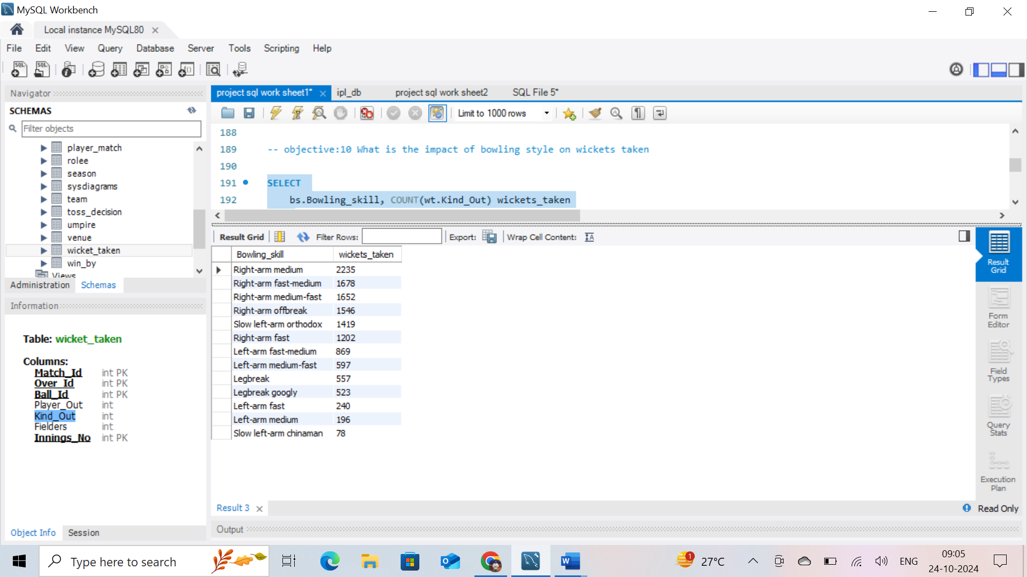

1. Write the sql query to provide a status of whether the performance of the team better than the previous year performance on the basis of number of runs scored by the team in the season and number of wickets taken

**Ans:** To get the above task

* I used 3 CTE’s named as “Runs_Per_Season”,” Wickets_Per_Season”,

” Performance” to create I used tables to join primary and foreign keys

Below table

* Tables used for joining ‘’ Season’’,” Matches”,” Batsman_Scored”, and “Wicket_Taken”
* I used to filter with where clause to find teams ,also used count and sum for finding total_runs,total_wickets.
* I used lag for previous year resuts,and case statement for finding performance_status.

-------------------------------------------------------------------------------------------------------------------

**Coding:**

WITH Runs_Per_Season AS

(SELECT s.Season_Year, SUM(b.Runs_Scored) AS Total_Runs

FROM Season s

JOIN Matches m ON s.Season_Id = m.Season_Id

JOIN Batsman_Scored b ON m.Match_Id = b.Match_Id

WHERE (m.Team_1 = 2 AND b.Innings_No = 1) OR (m.Team_2 = 2 AND b.Innings_No = 2)

GROUP BY s.Season_Year)

,

Wickets_Per_Season AS

(SELECT s.Season_Year, COUNT(w.Player_Out) AS Total_Wickets

FROM Season s

JOIN Matches m ON s.Season_Id = m.Season_Id

JOIN Wicket_Taken w ON m.Match_Id = w.Match_Id

WHERE (m.Team_1 = 2 AND w.Innings_No = 2) OR (m.Team_2 = 2 AND w.Innings_No = 1)

GROUP BY s.Season_Year)

,

Performance AS

(SELECT r.Season_Year, r.Total_Runs, w.Total_Wickets,

LAG(r.Total_Runs) OVER (ORDER BY r.Season_Year) AS Prev_Season_Runs,

LAG(w.Total_Wickets) OVER (ORDER BY w.Season_Year) AS Prev_Season_Wickets

FROM Runs_Per_Season r

JOIN Wickets_Per_Season w ON r.Season_Year = w.Season_Year

)

SELECT Season_Year, Total_Runs, Total_Wickets, Prev_Season_Runs,Prev_Season_Wickets,

CASE WHEN Total_Runs > Prev_Season_Runs AND Total_Wickets > Prev_Season_Wickets

THEN 'Better' ELSE 'Worse' END AS Performance_Status

FROM Performance;

**sample data as output:**

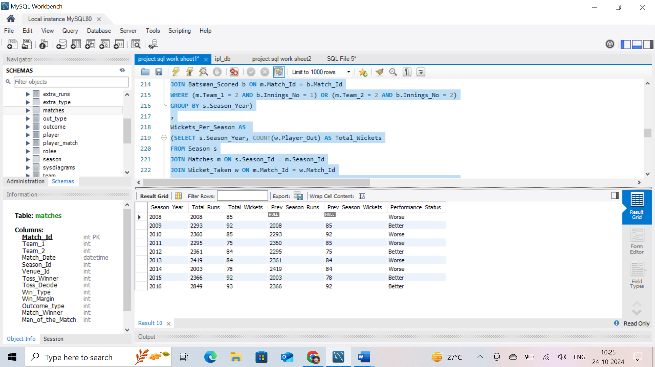

1. Can you derive more KPIs for the team strategy if possible?

**Ans:**

**Coding:**

Batting

--------

WITH match_detail AS

(SELECT Match_Id , Team_1 , Team_2 , Toss_Winner , Toss_Decide ,

CASE WHEN Toss_Winner = 2 AND Toss_Decide = 1 THEN 2

WHEN Toss_Winner = 2 AND Toss_Decide = 2 THEN 1

WHEN Toss_Winner !=2 AND Toss_Decide = 1 THEN 1

WHEN Toss_Winner !=2 AND Toss_Decide = 2 THEN 2 END AS Innings

FROM matches

WHERE Team_1 = 2 OR Team_2 = 2)

,

Runs_from_bat AS

(SELECT SUM(bs.Runs_Scored) AS total

FROM batsman_scored bs

JOIN match_detail md

ON md.Match_Id = bs.Match_Id AND bs.Innings_No = md.Innings)

-- bs.Over_Id BETWEEN 7 and 15

-- bs.Over_Id < 6

-- bs.Over_Id > 15

,

Runs_from_extra AS

(SELECT sum(er.Extra_Runs) total

FROM extra_runs er

JOIN match_detail md

ON er.Match_Id = md.Match_Id AND er.Innings_No = md.Innings)

-- bs.Over_Id BETWEEN 7 and 15

-- bs.Over_Id < 6

-- bs.Over_Id > 15

SELECT SUM(runs.total) Total_runs_by_RCB_in_Season_1

FROM

(SELECT total FROM Runs_from_bat rb

UNION ALL

SELECT total FROM Runs_from_extra re) runs;

Bowling

-------

WITH match_detail AS

(SELECT Match_Id , Team_1 , Team_2 , Toss_Winner , Toss_Decide ,

CASE WHEN Toss_Winner = 2 AND Toss_Decide = 1 THEN 2

WHEN Toss_Winner = 2 AND Toss_Decide = 2 THEN 1

WHEN Toss_Winner !=2 AND Toss_Decide = 1 THEN 1

WHEN Toss_Winner !=2 AND Toss_Decide = 2 THEN 2 END AS Innings

FROM matches

WHERE (Team_1 = 2 OR Team_2 = 2))

SELECT COUNT(wt.Kind_Out)

FROM wicket_taken wt

JOIN match_detail md

ON wt.Match_Id = md.Match_Id AND wt.Innings_No = md.Innings

-- WHERE wt.Over_Id < 7

-- WHERE wt.Over_Id between 7 and 15

-- WHERE wt.Over_Id > 15

* **Powerplay Performance (1-6 Overs)**RCB Team Runs in Powerplay : 6056  
  RCB Team Wickets Taken in Powerplay : 201
* **Death Overs Performance (16 – 20 Overs)**RCB Team Runs in Death Overs : 6460  
  RCB Team Wickets Taken in Death Overs : 276
* **Middle Over Performance (7-15 Overs)**   
   RCB Team Runs in Middle Overs : 9463  
   RCB Team Wickets in Middle Overs : 293
* **RCB Team Total Runs Scored - 21547**
* **RCB Team Total Wickets Taken - 770**
* **TOP 5 RUNS SCORERS IN RCB HOME**

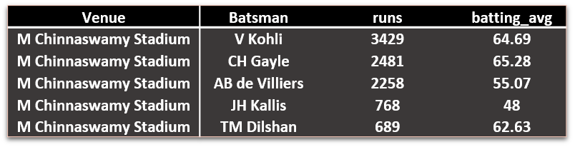

* **TOP 5 WICKET TAKERS IN RCB HOME**

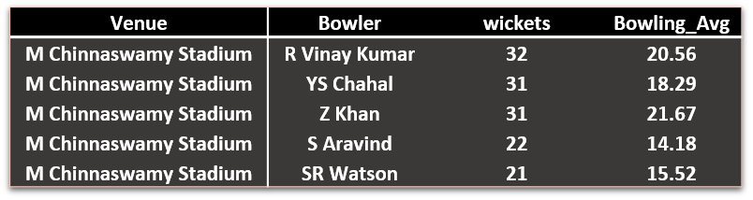

* **RCB HOME MATCHES RECORD**

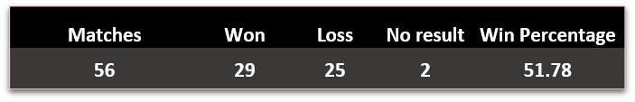

* **Most Runs**

Most runs scored for RCB by Indian player : V Kohli  
 Most runs scored for RCB by Overseas player : CH Gayle

* **Most Wickets**Most wickets taken for by Indian Player : YS chahal  
  Most wickets taken for by Overseas Player : DW Steyn

1. Using SQL, write a query to find out average wickets taken by each bowler in each venue. Also rank the gender according to the average value.

**Ans:** To find out the performance of each bowler on each venue

* I used 2 CTE’s named as “runs_consided”,” wickets_taken”. I used tables to join primary and foreign keys Below table
* Tables used for joining ‘’ ball_by_ball’’,” Matches”,” Batsman_Scored”, and “Wicket_Taken”
* I used dense_rank for ranking, and joined the comman elements above 2 CTE’s in the main query.

-------------------------------------------------------------------------------------------------------------------

**Coding:**

WITH runs_consided AS

(SELECT v.Venue_Id , bb.Bowler , SUM(bs.Runs_Scored) runs_given

FROM matches m

JOIN venue v ON v.Venue_Id = m.Venue_Id

JOIN ball_by_ball bb ON m.Match_Id = bb.Match_Id

JOIN batsman_scored bs ON bb.Match_Id = bs.Match_Id AND bb.Over_Id = bs.Over_Id AND bb.Ball_Id = bs.Ball_Id AND bb.Innings_No = bs.Innings_No

GROUP BY v.Venue_Id , bb.Bowler

ORDER BY v.Venue_Id),

wickets_taken AS

(SELECT v.Venue_Id , bb.Bowler , COUNT(wt.Kind_Out) wickets

FROM matches m

JOIN venue v ON v.Venue_Id = m.Venue_Id

JOIN ball_by_ball bb ON m.Match_Id = bb.Match_Id

JOIN wicket_taken wt ON bb.Match_Id = wt.Match_Id AND bb.Over_Id = wt.Over_Id AND bb.Ball_Id = wt.Ball_Id AND bb.Innings_No = wt.Innings_No

GROUP BY v.Venue_Id , bb.Bowler

ORDER BY v.Venue_Id)

SELECT rc.Venue_Id , v.Venue_Name , rc.Bowler , p.Player_Name , rc.runs_given , wt.wickets , rc.runs_given/wt.wickets AS Bowling_AVG,

dense_rank() OVER (ORDER BY rc.runs_given/wt.wickets) AS Ranks_by_avg_in_venue

FROM runs_consided rc

JOIN wickets_taken wt

ON rc.Venue_Id = wt.Venue_Id AND rc.Bowler = wt.Bowler

JOIN player p

ON p.Player_Id = rc.Bowler

JOIN venue v

ON v.Venue_Id = rc.Venue_Id;

**Some data as result;**

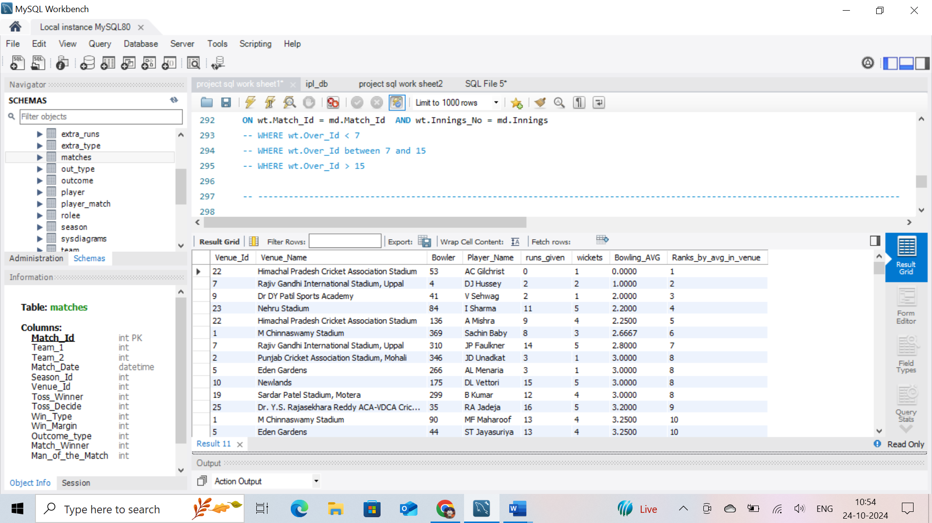

1. Which of the given players have consistently performed well in past seasons? (will you use any visualisation to solve the problem)

Ans: To get above data,

**I used consistence batter's:**

* I created a CTE name as “details” with joining required tables like “ball_by_ball”,

” batsman_scored”,” player”,” matches” with their primary and foreign keys to get a data in 1 table.

* From main query, I create a sub query I filtered runs greater than 700 runs with in past 4 seasons by where clause , and by using having clause.

**I used consistence bowler's**:

* I created a 2 CTE’s names “runs_given_details”,” wickets_taken_details”
* I have joined the tables “ball_by_ball”,” batsman_scored”,” matches”,” wicket_taken” with their primary and foreign keys to get a data in 1 table.

In main query , I have joined both 2 CTE’s and with “player” tables with their primary and foreign keys to get a data in 1 table.

* From main query, I create a sub query I filtered runs greater than 15 wickets with in past 4 seasons by where clause , and by using having clause.

**I used ALL rounder consistence both in bat and bowl:**

* For batting I used a CTE “deatil”and for bowling I used 2CTE’s “runs_consided”,”wickets_taken”
* I have joined the tables “ball_by_ball”,” batsman_scored”,” matches”,” wicket_taken” ,”player”with their primary and foreign keys to get a data in 1 table.

In main query , I have joined both 2 CTE’s and with “player” tables with their primary and foreign keys to get a data in 1 table.

* From main query, in batting I create a sub query I filtered runs greater than 400 runs with in past 4 seasons by where clause , and by using having clause.
* From main query, I create a sub query I filtered runs greater than 8 wickets with in past 4 seasons by where clause , and by using having clause.

**Coding:**

consistence batter's:

with details as (

select p.Player_Name,m.Season_Id,count(distinct bs.Match_Id) matches_played , sum(bs.Runs_Scored) runs,

sum(bs.Runs_Scored)/count(distinct bs.Match_Id) avg_runs

from ball_by_ball bb

join batsman_scored bs

on bb.Match_Id = bs.Match_Id and bb.Over_Id = bs.Over_Id and bb.Ball_Id = bs.Ball_Id

join player p

on p.Player_Id = bb.Striker

join matches m

on m.Match_Id = bb.Match_Id

group by p.Player_Name,m.Season_Id)

select Player_Name, count(*) consistence

from

(select d.player_name,d.Season_Id,d.matches_played,d.runs,d.avg_runs batting_average

from details d

where d.runs >= 700) me

group by Player_Name

having count(*) >= 4;

* Out of 9 seasons – 4 seasons (They scored more then 700 runs)
* Above query will give us the consistence batsmen in overall seasons of the IPL

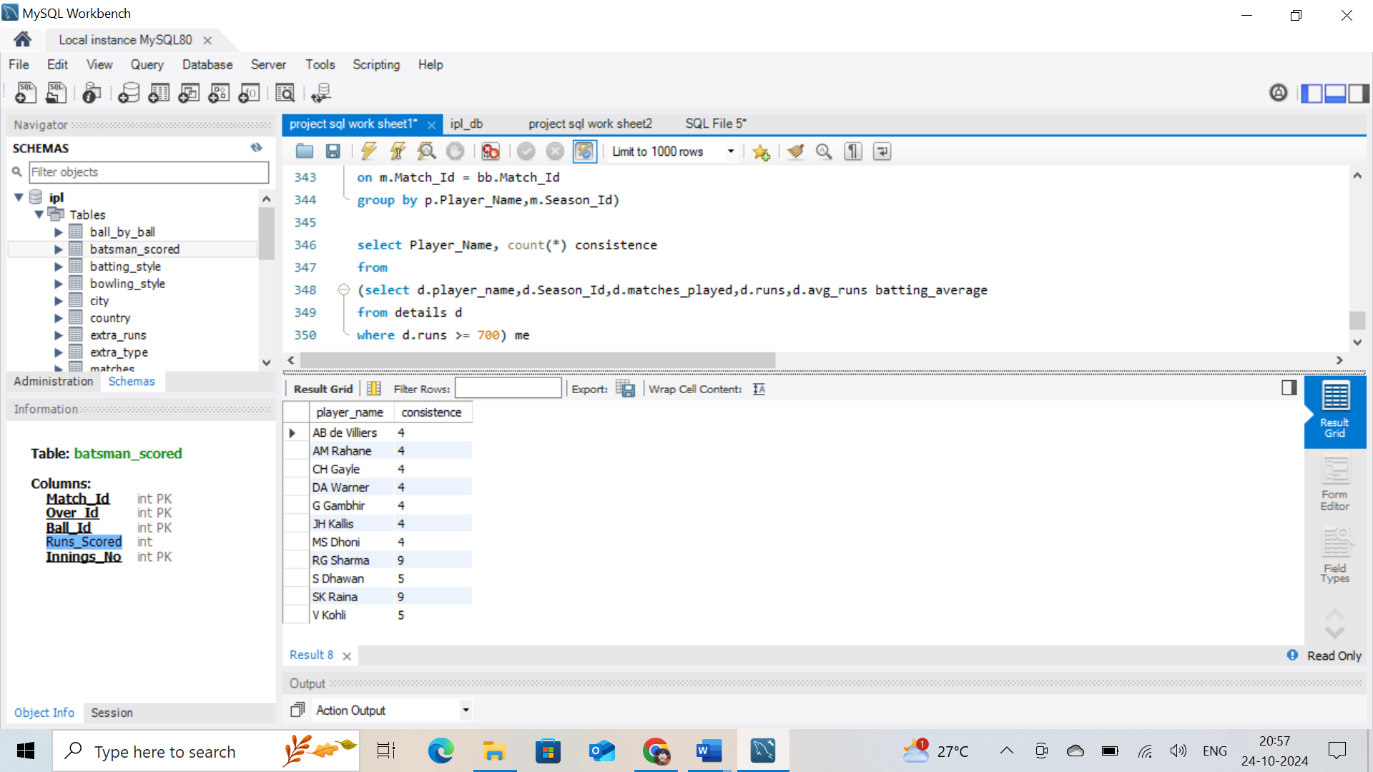

**Visual output:**

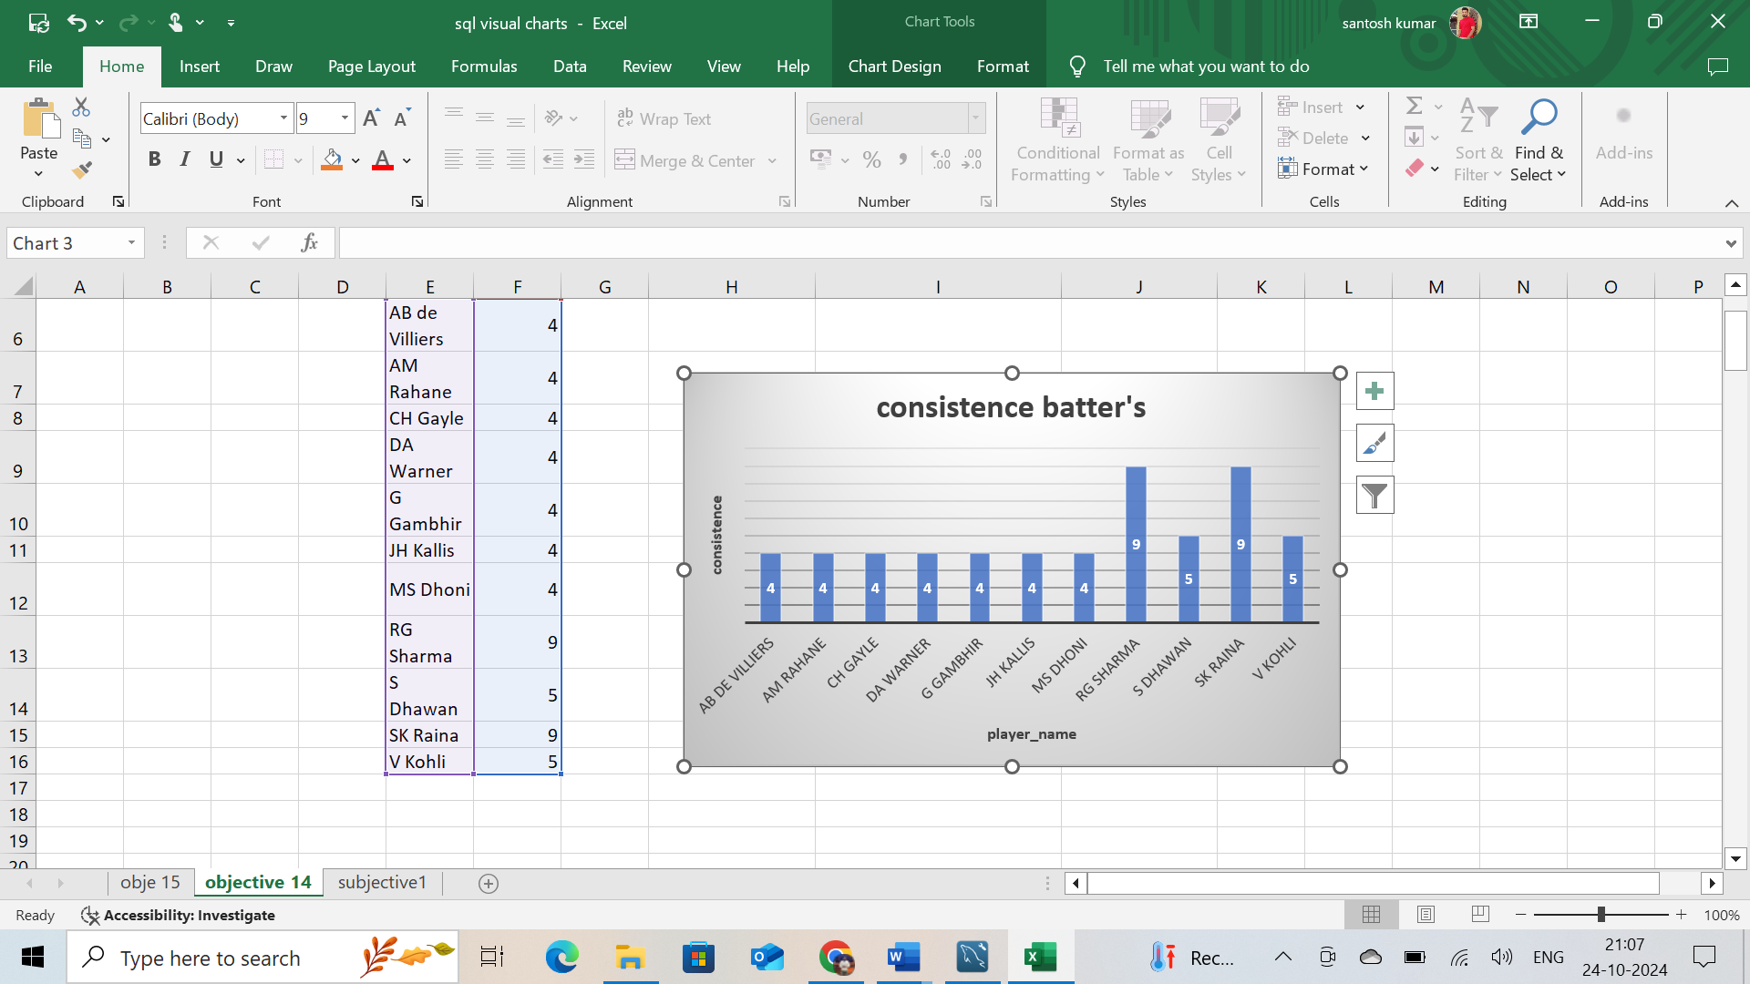

**Coding:**

consistence bowler’s:

with runs_given_details as (

select bb.Bowler,m.Season_Id,sum(bs.Runs_Scored) runs_given

from ball_by_ball bb

join batsman_scored bs

on bb.Match_Id = bs.Match_Id and bb.Over_Id = bs.Over_Id and bb.Ball_Id = bs.Ball_Id and bb.Innings_No = bs.Innings_No

join matches m

on m.Match_Id = bb.Match_Id

group by bb.Bowler,m.Season_Id),

wickets_taken_details as (

select bb.Bowler,m.Season_Id,count(wt.Kind_Out) wickets_taken

from ball_by_ball bb

join wicket_taken wt

on bb.Match_Id = wt.Match_Id and bb.Over_Id = wt.Over_Id and bb.Ball_Id = wt.Ball_Id and bb.Innings_No = wt.Innings_No

join matches m

on m.Match_Id = bb.Match_Id

group by bb.Bowler,m.Season_Id)

select Player_Name, count(*) consistence

from

(select p.player_name,rd.Season_Id,rd.runs_given,wd.wickets_taken,rd.runs_given/wd.wickets_taken as bowling_average

from runs_given_details rd

join wickets_taken_details wd

on rd.Bowler = wd.Bowler and rd.Season_Id = wd.Season_Id

join player p

on p.Player_Id = rd.Bowler

where wd.wickets_taken >= 15) me

group by Player_Name

having count(*) >= 4;

* Above query will give us consistence bowler in overall seasons of the IPL

Out of 9 seasons – 4 seasons (They took 15 wickets)

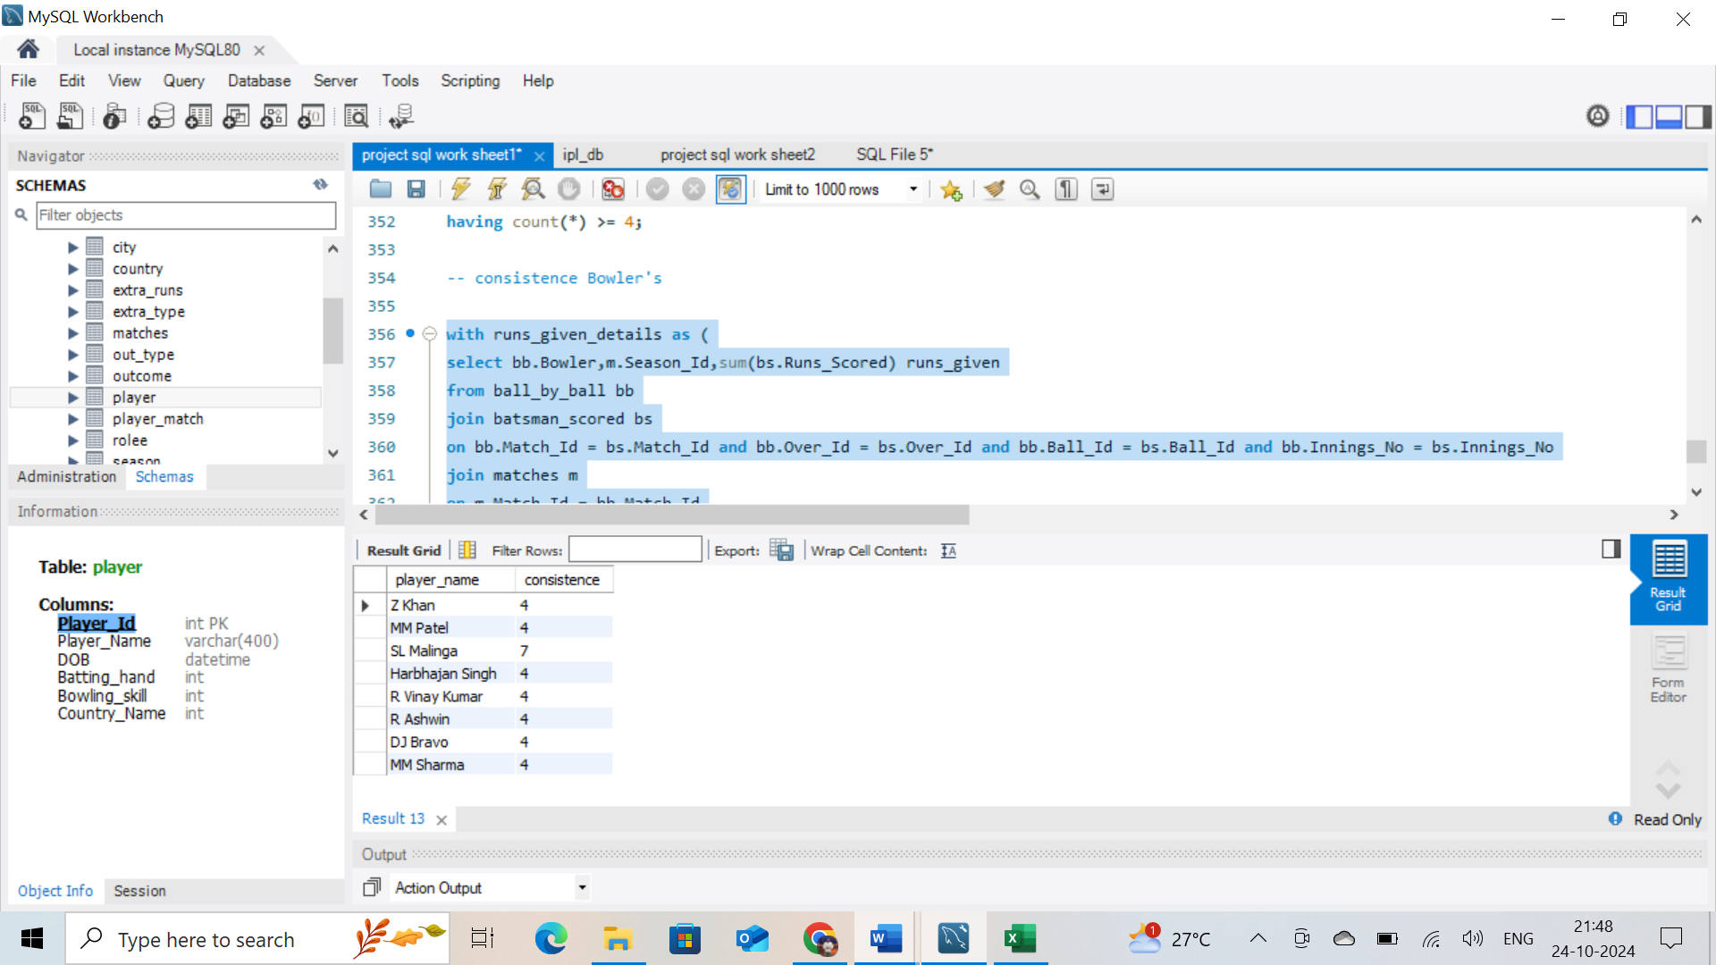

**visual ouput:**

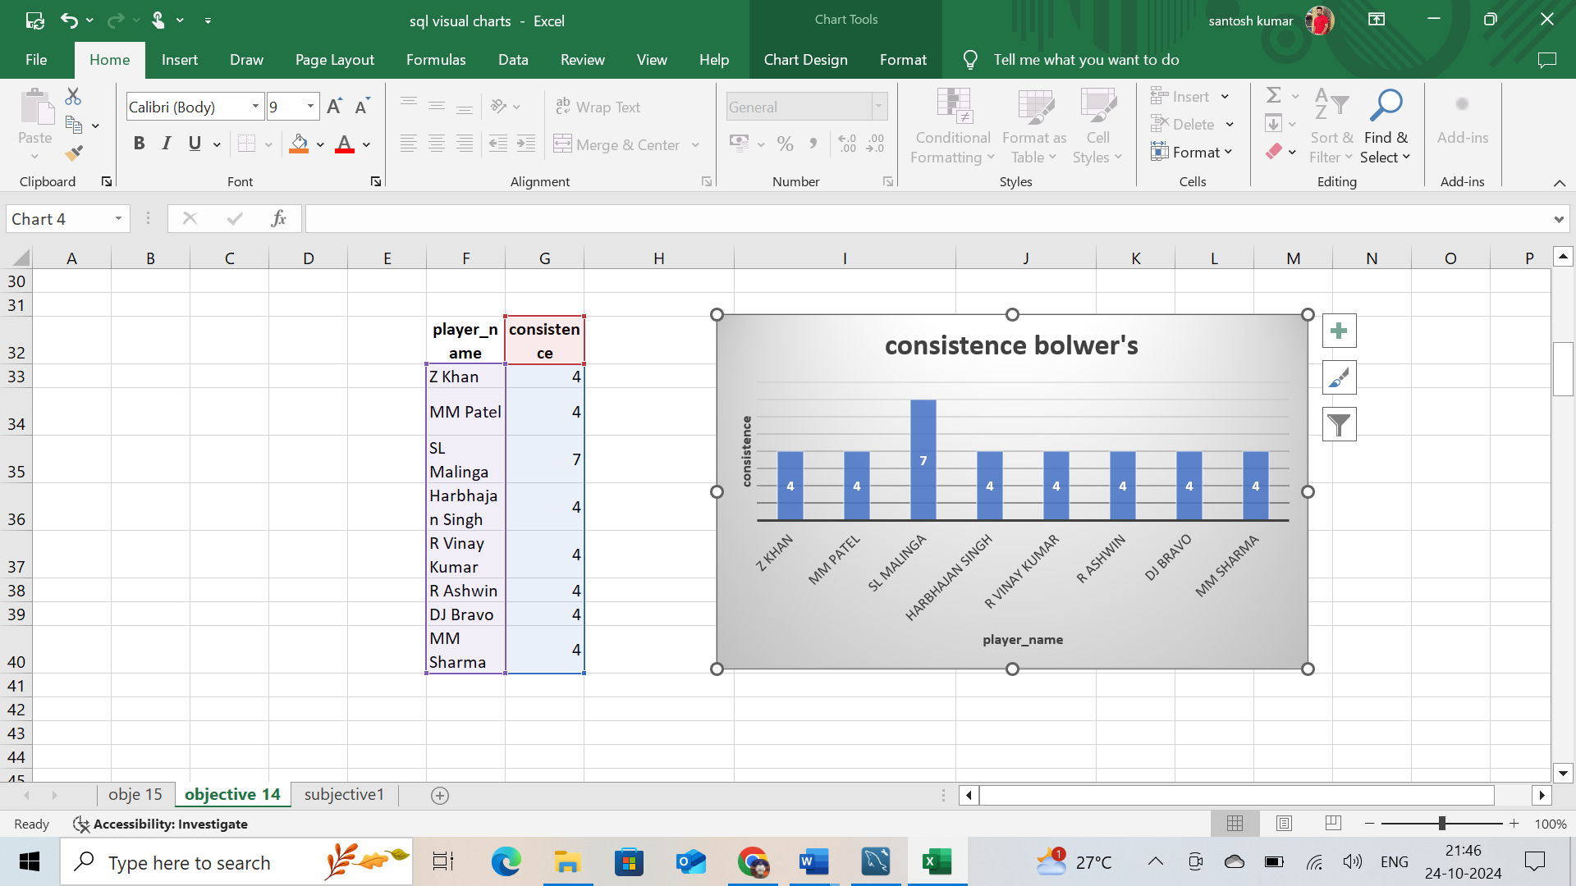

consistence All rounders:

bat:

with detail as

(select p.Player_Name , m.Season_Id, count(distinct bs.Match_Id) Matches_played , sum(bs.Runs_Scored) runs,

sum(bs.Runs_Scored)/count(distinct bs.Match_Id) average_runs

from ball_by_ball bb

join batsman_scored bs

on bb.Match_Id = bs.Match_Id and bb.Over_Id = bs.Over_Id and bb.Ball_Id = bs.Ball_Id

join player p

on p.Player_Id = bb.Striker

join matches m

on m.Match_Id = bb.Match_Id

group by p.Player_Name,m.Season_Id)

select Player_Name , count(*) consistence

from

(select d.Player_Name ,d.Season_Id , d.Matches_played , d.runs , d.average_runs batting_average

from detail d

where d.runs >= 400) me

group by Player_Name

having count(*) >= 4;

**sample output for all_rounder in batting:**

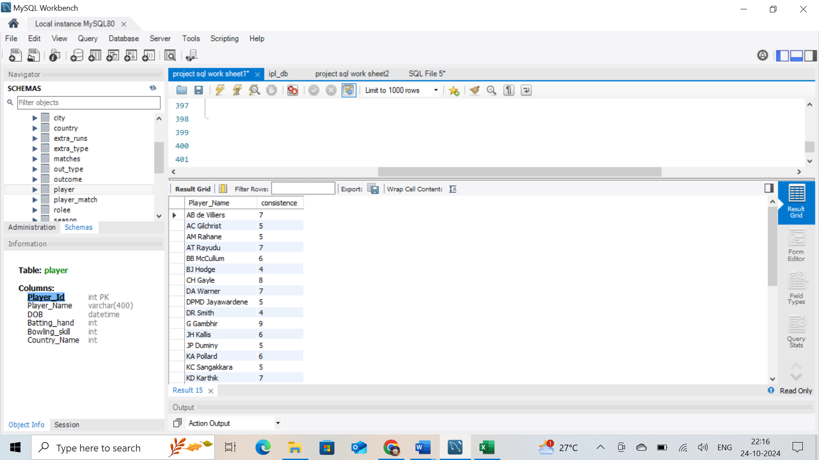

**visual output**

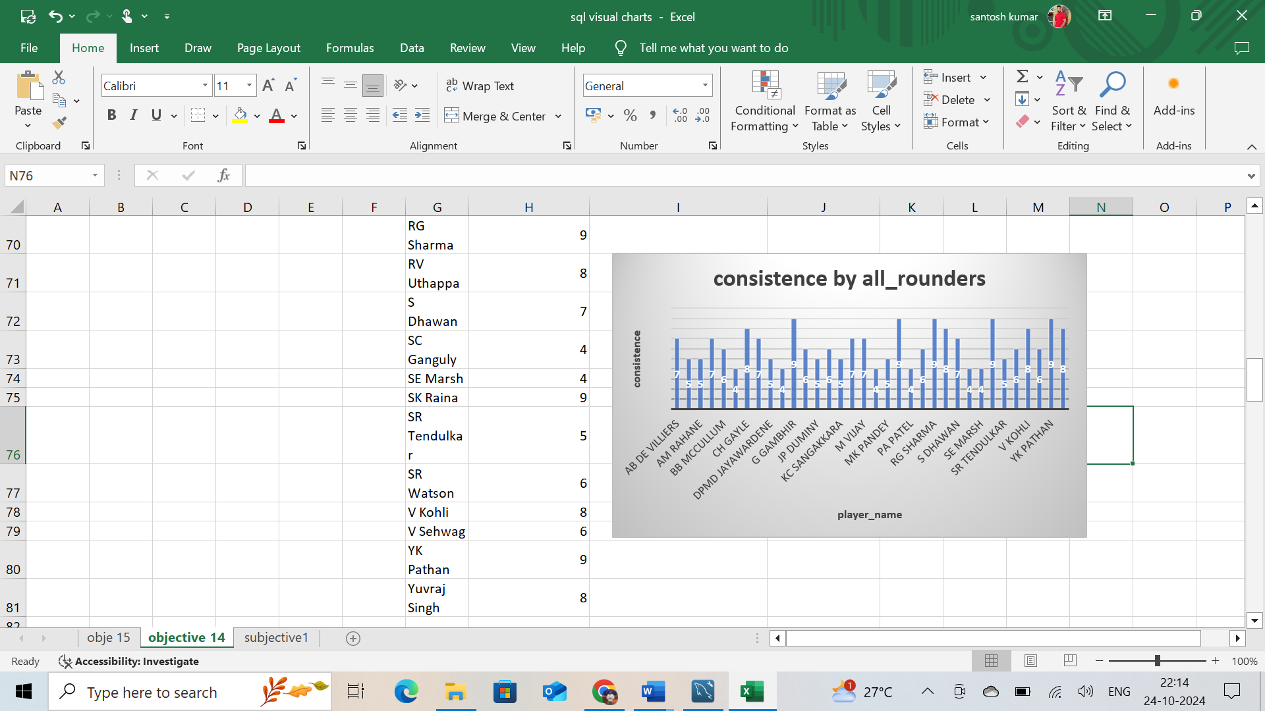

Bowl:

with runs_consided as

(select bb.Bowler , m.Season_Id ,sum(bs.Runs_Scored) runs_given

from ball_by_ball bb

join batsman_scored bs

on bb.Match_Id = bs.Match_Id and bb.Over_Id = bs.Over_Id and bb.Ball_Id = bs.Ball_Id and bb.Innings_No = bs.Innings_No

join matches m

on m.Match_Id = bb.Match_Id

group by bb.Bowler , m.Season_Id)

,

wickets_taken as

(select bb.Bowler , m.Season_Id ,COUNT(wt.Kind_Out) wickets

from ball_by_ball bb

join wicket_taken wt

on bb.Match_Id = wt.Match_Id and bb.Over_Id = wt.Over_Id and bb.Ball_Id = wt.Ball_Id and bb.Innings_No = wt.Innings_No

join matches m

on m.Match_Id= bb.Match_Id

group by bb.Bowler , m.Season_Id)

select Player_Name , count(*) consistance

from

(select p.Player_Name,rc.Season_Id ,rc.runs_given , wt.wickets , rc.runs_given / wt.wickets AS bowling_average

from runs_consided rc

join wickets_taken wt

on rc.Bowler = wt.Bowler and rc.Season_Id = wt.Season_Id

join player p

on p.Player_Id = rc.Bowler

where wt.wickets >= 8) me

group by Player_Name

having count(*) >= 4;

**sample output for all_rounder in batting:**

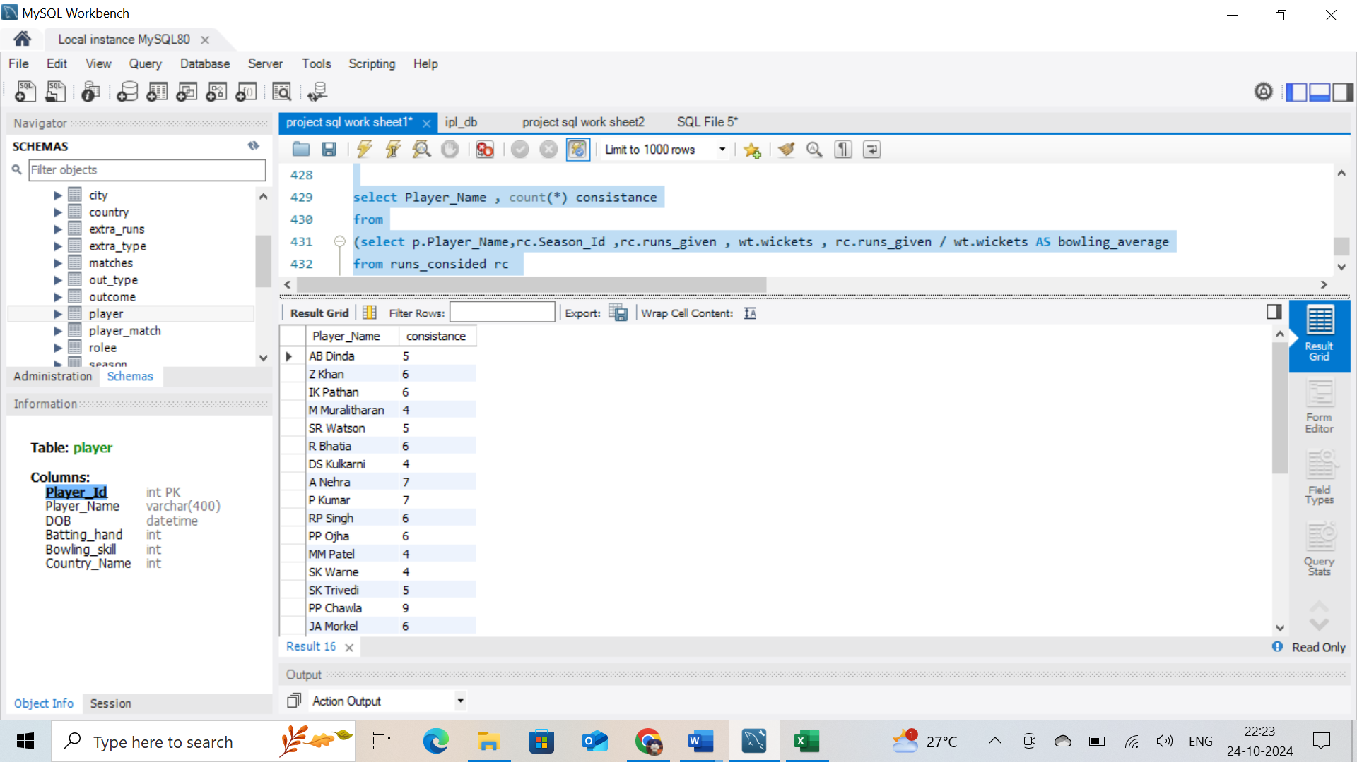

**Visual output:**

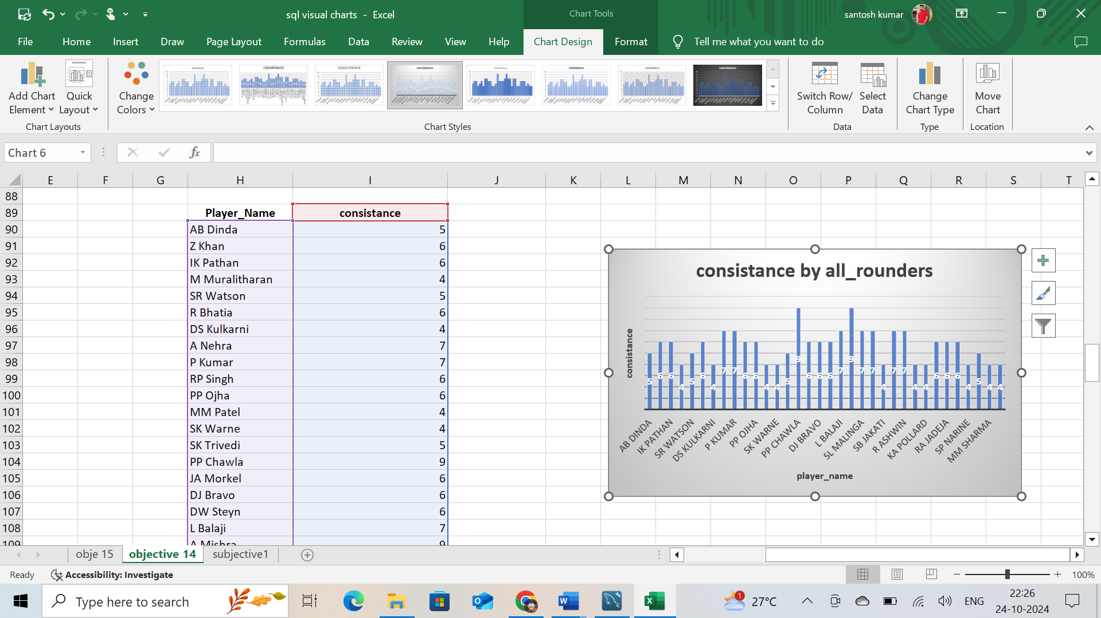

* we can take the common players in above both the list (batter and bowler ) and we can find out the All rounder’s in overall seasons of the IPL
* Out of 9 seasons – 4 seasons (They scored more then 400 runs and took 8 wickets)  
    
  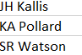

1. Are there players whose performance is more suited to specific venues or conditions? (how would you present this using charts?)

**Coding:** to get above data

* **For bat:** I used 2 CTE’s names as “detail” and “detail_by_rank” using tables . I have joined the tables “ball_by_ball”,” batsman_scored”,” matches”,” wicket_taken” ,”player”with their primary and foreign keys to get a data in 1 table.
* By using CTE“detail” ,finding dense_rank. And by using main query joined CTE “detail_by_rank”. Joined table to venus to find required output,filter in where clause for ranking .
* **For bowl:** I used 3 CTE’s names as “runs_considered”,”wickets_taken” and “”,“detail_by_rank” using tables . I have joined the tables “ball_by_ball”,” batsman_scored”,” matches”,” wicket_taken” ,”player”with their primary and foreign keys to get a data in 1 table.
* By using CTE“detail” ,finding dense_rank. And by using main query joined CTE “detail_by_rank”. Joined table to venus to find required output,filter in where clause for ranking .

Bat:

WITH detail AS

(SELECT m.Venue_Id , p.Player_Name , COUNT(DISTINCT bs.Match_Id) Matches_played ,

SUM(bs.Runs_Scored) runs, SUM(bs.Runs_Scored)/COUNT(DISTINCT bs.Match_Id) batting_avg

FROM ball_by_ball bb

JOIN batsman_scored bs

ON bb.Match_Id = bs.Match_Id AND bb.Over_Id = bs.Over_Id AND bb.Ball_Id = bs.Ball_Id

JOIN matches m

ON m.Match_Id = bb.Match_Id

JOIN player p

ON p.Player_Id = bb.Striker

GROUP BY m.Venue_Id , p.Player_Name)

,

detail_by_rank AS

(SELECT d.Venue_Id , d.Player_Name , d.Matches_played , d.runs , d.batting_avg ,

dense_rank() OVER (partition by d.Venue_Id ORDER BY d.runs DESC , d.batting_avg) as Ranks

FROM detail d)

SELECT v.Venue_Name , dr.*

FROM detail_by_rank dr

JOIN venue v

ON dr.Venue_Id = v.Venue_Id

WHERE dr.Ranks <= 3;

**Sample output data for batters:**

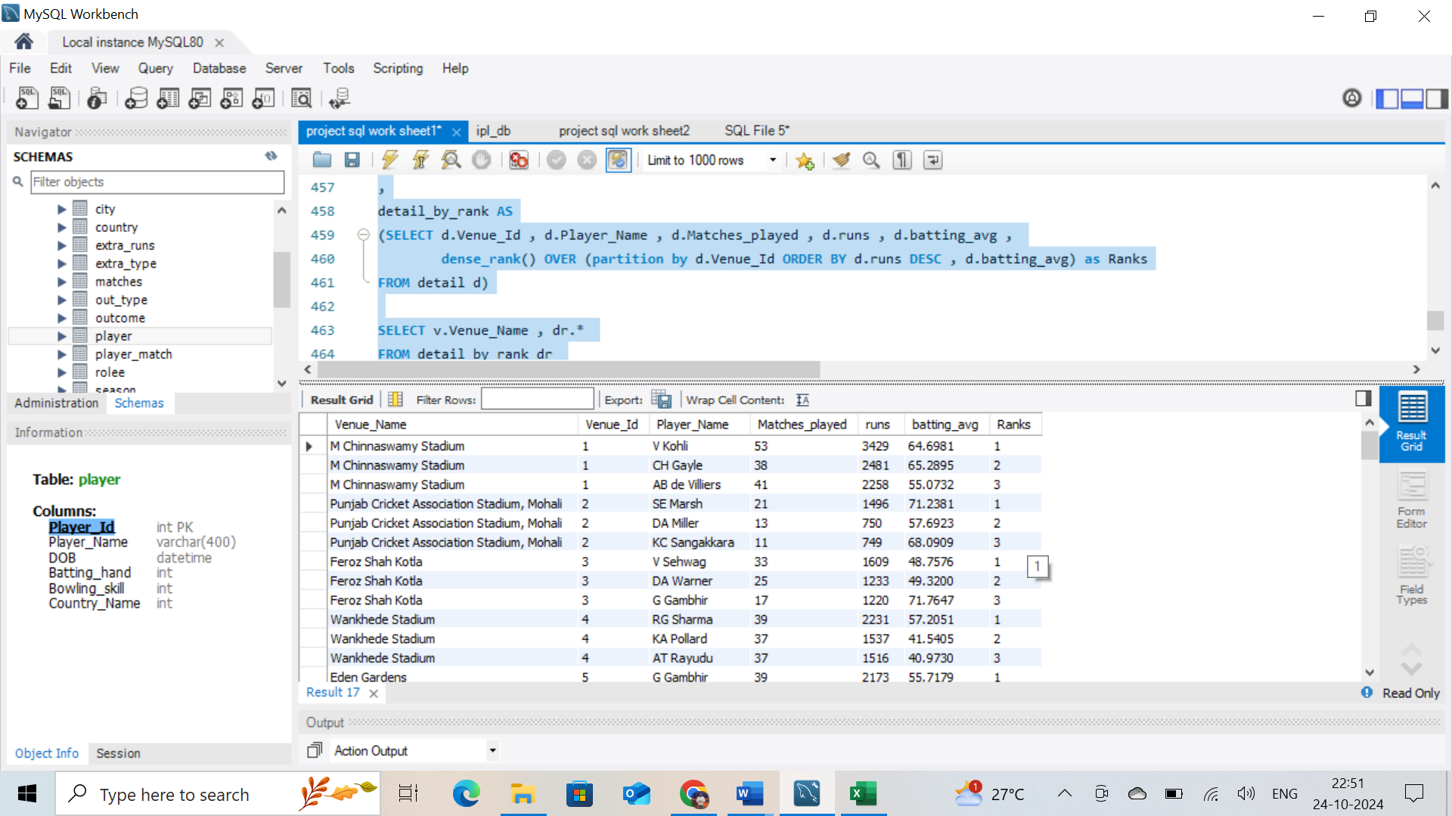

Bowl:

**Coding:**

WITH runs_consided AS

(select m.Venue_Id , bb.Bowler , SUM(bs.Runs_Scored) runs_given

FROM ball_by_ball bb

JOIN batsman_scored bs

ON bb.Match_Id = bs.Match_Id AND bb.Over_Id = bs.Over_Id AND bb.Ball_Id = bs.Ball_Id AND bb.Innings_No = bs.Innings_No

JOIN matches m

ON m.Match_Id= bb.Match_Id

GROUP BY m.Venue_Id , bb.Bowler)

,

wickets_taken AS

(select m.Venue_Id, bb.Bowler , COUNT(wt.Kind_Out) wickets

FROM ball_by_ball bb

JOIN wicket_taken wt

ON bb.Match_Id = wt.Match_Id AND bb.Over_Id = wt.Over_Id AND bb.Ball_Id = wt.Ball_Id AND bb.Innings_No = wt.Innings_No

JOIN matches m

ON m.Match_Id= bb.Match_Id

GROUP BY m.Venue_Id , bb.Bowler)

,

Details_by_Rank AS

(SELECT rc.Venue_Id , rc.Bowler ,p.Player_Name , rc.runs_given , wt.wickets , rc.runs_given / wt.wickets AS bowling_average ,

dense_rank() OVER (partition by rc.Venue_Id ORDER BY wt.wickets DESC , rc.runs_given / wt.wickets ASC ) Ranks

FROM runs_consided rc

JOIN wickets_taken wt

ON rc.Venue_Id = wt.Venue_Id AND rc.Bowler = wt.Bowler

JOIN player p

ON p.Player_Id = rc.Bowler)

SELECT v.Venue_Name , dr.*

FROM Details_by_Rank dr

JOIN venue v

ON v.Venue_Id = dr.Venue_Id

WHERE dr.Ranks <= 3;

**Sample output data for bolwer’s:**

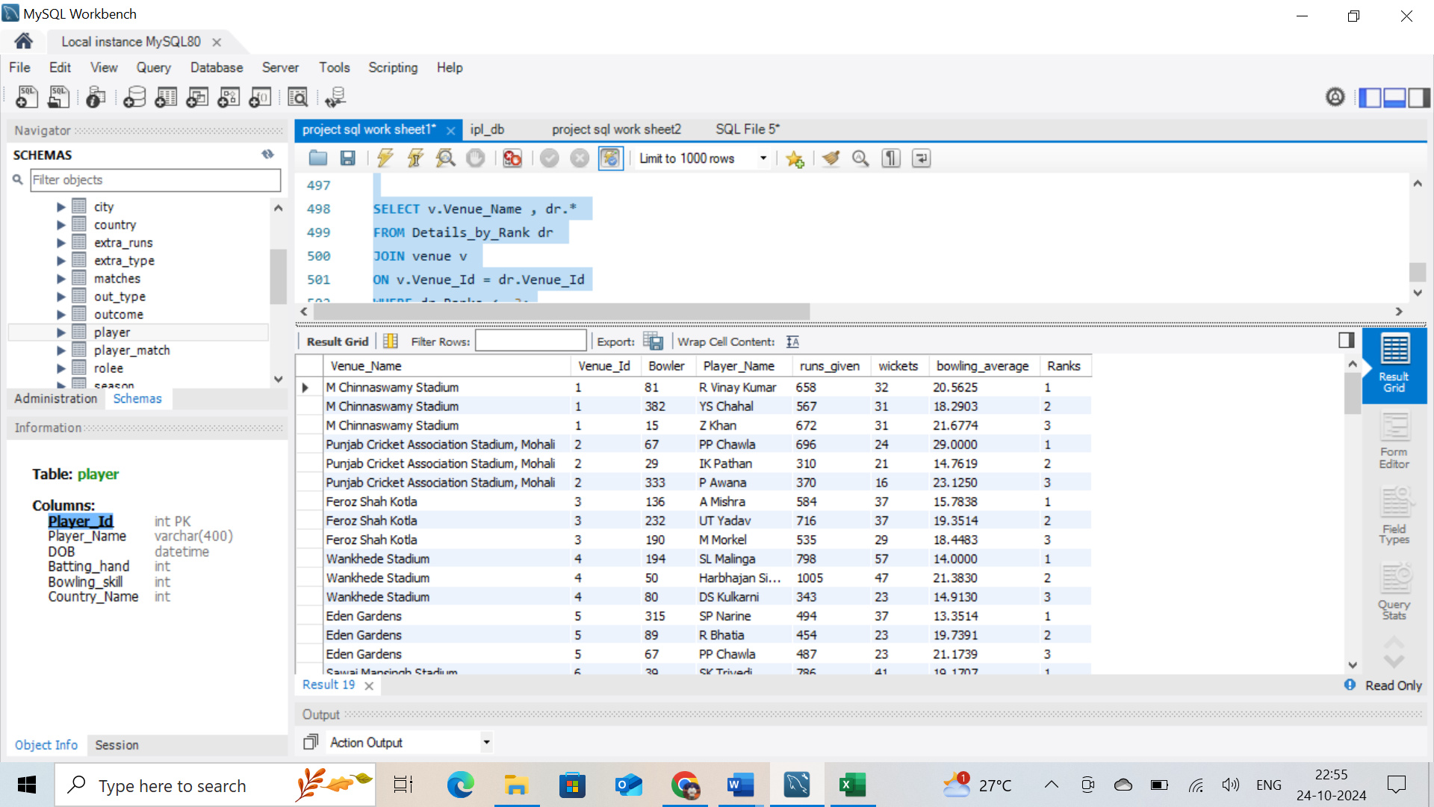

**SUBJECTIVE QUESTIONS:**

1. How does toss decision have affected the result of the match ? (which visualisations could be used to better present your answer) And is the impact limited to only specific venues?

**Answer:**

-- total number of matches

SELECT count(Match_Id) total_matches

FROM matches;

-- Number of matches won afer wining the toss

SELECT COUNT(*) Matches_and_toss_won

FROM matches

WHERE Toss_Winner = Match_Winner AND Win_Type in (1,2,4);

-- Matches won after tos winning as per venue

SELECT v.Venue_Name , COUNT(m.Match_Id) matches , COUNT(CASE WHEN m.Toss_Winner = m.Match_Winner THEN 1 else NULL END ) AS toss_win_and_match_win,

COUNT(CASE WHEN m.Toss_Winner = m.Match_Winner THEN 1 else NULL END )/COUNT(m.Match_Id)*100 winning_percentage

FROM matches m

JOIN venue v

ON m.Venue_Id = v.Venue_Id

WHERE Win_Type in (1,2,4)

GROUP BY v.Venue_Name

**Sample output reference image:**

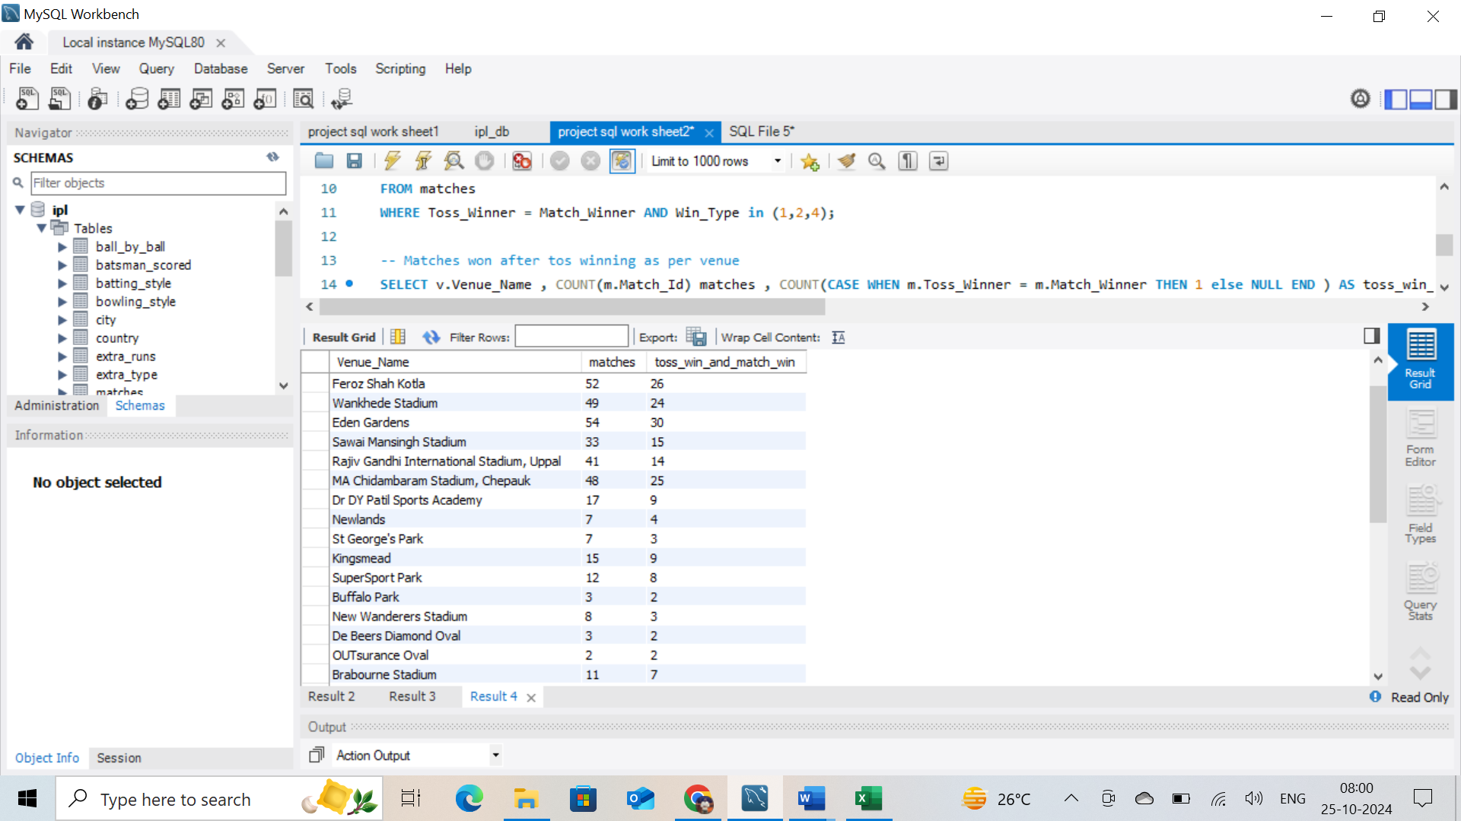

**Visual output:** using clustered column chart

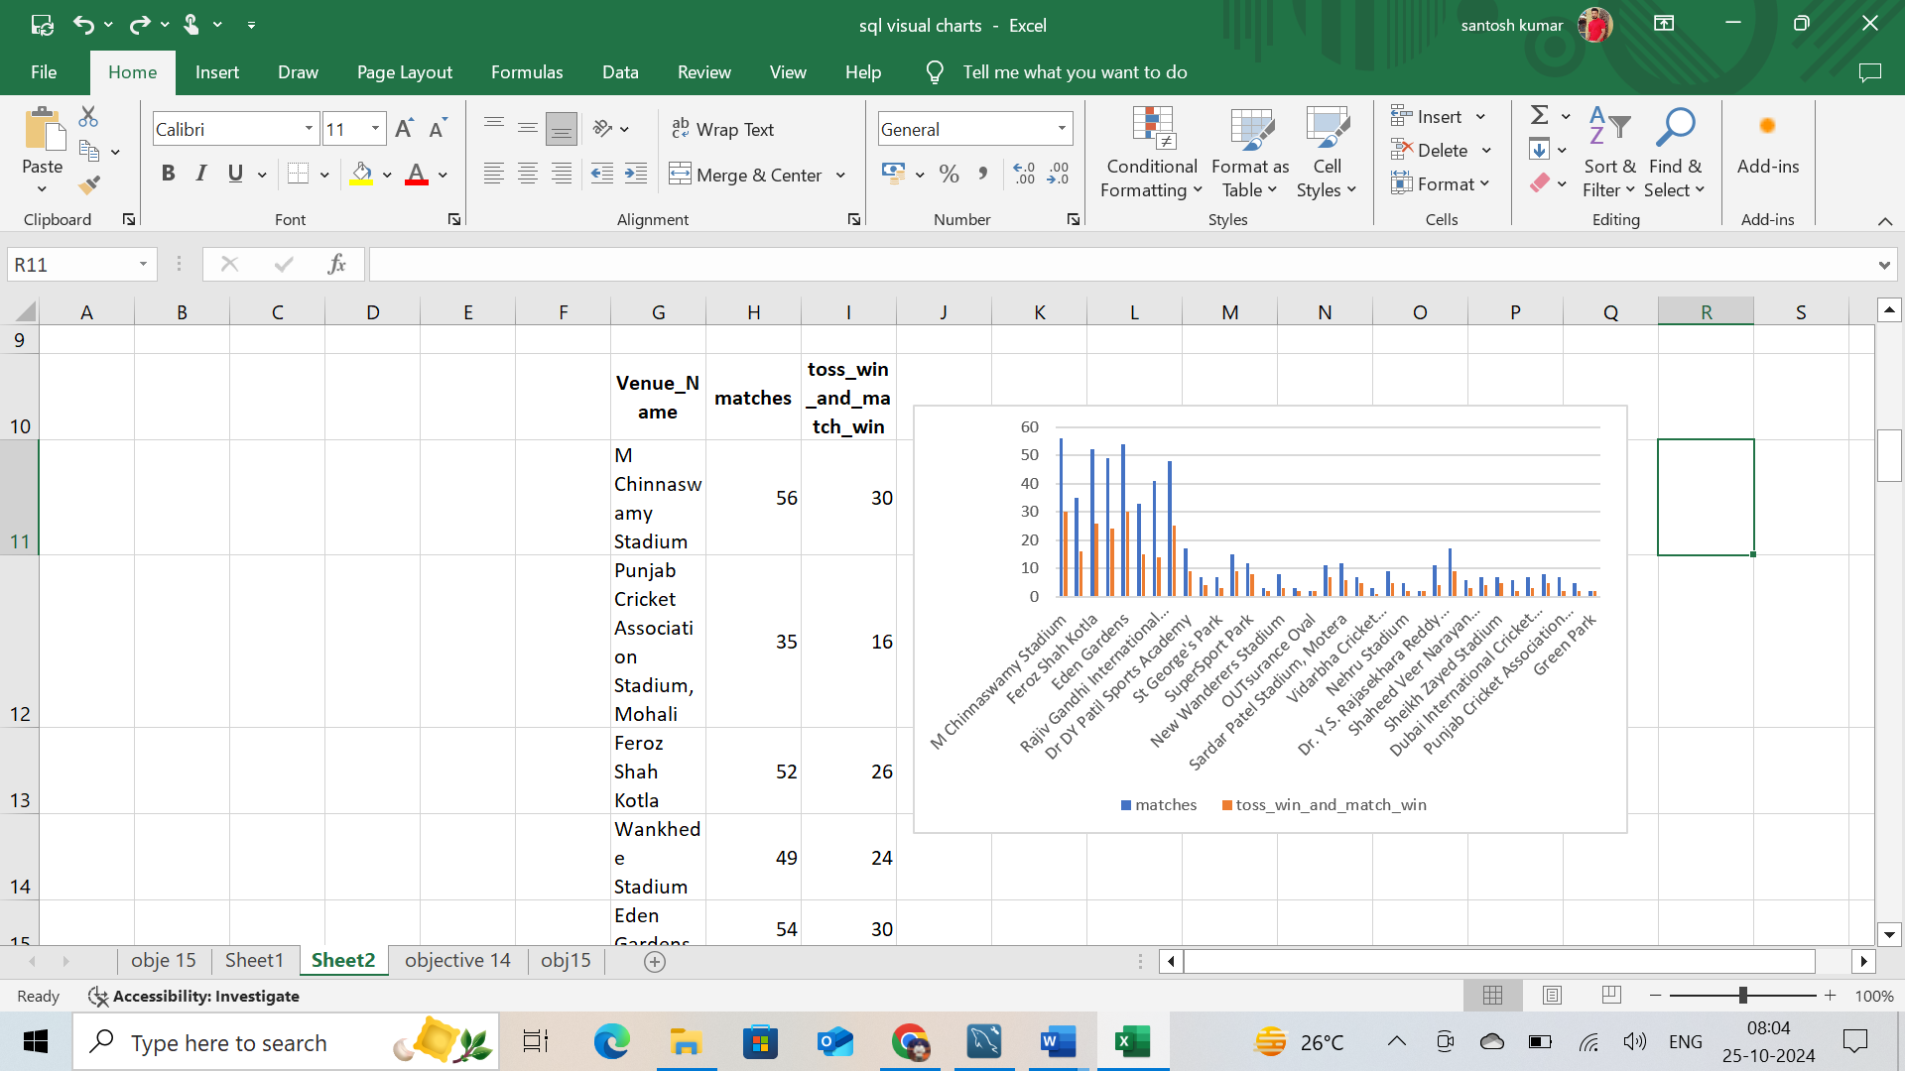

**Approach:**

* First calculated the total number of matches
* Then calculated Number of matches won after winning the toss
* Then based on the Venue calculated Number of matches won after winning the toss
* Lastly, calculated winning percentage of each venue after toss win

**Insights:**

* Using above query, we can find out
* Total Number of matches: 577
* Matches won after the toss win: 291
* Above table shows the matches won after winning the toss

**Recommendation** - Data represented from highest win percentage to low venue wise after winning the toss  
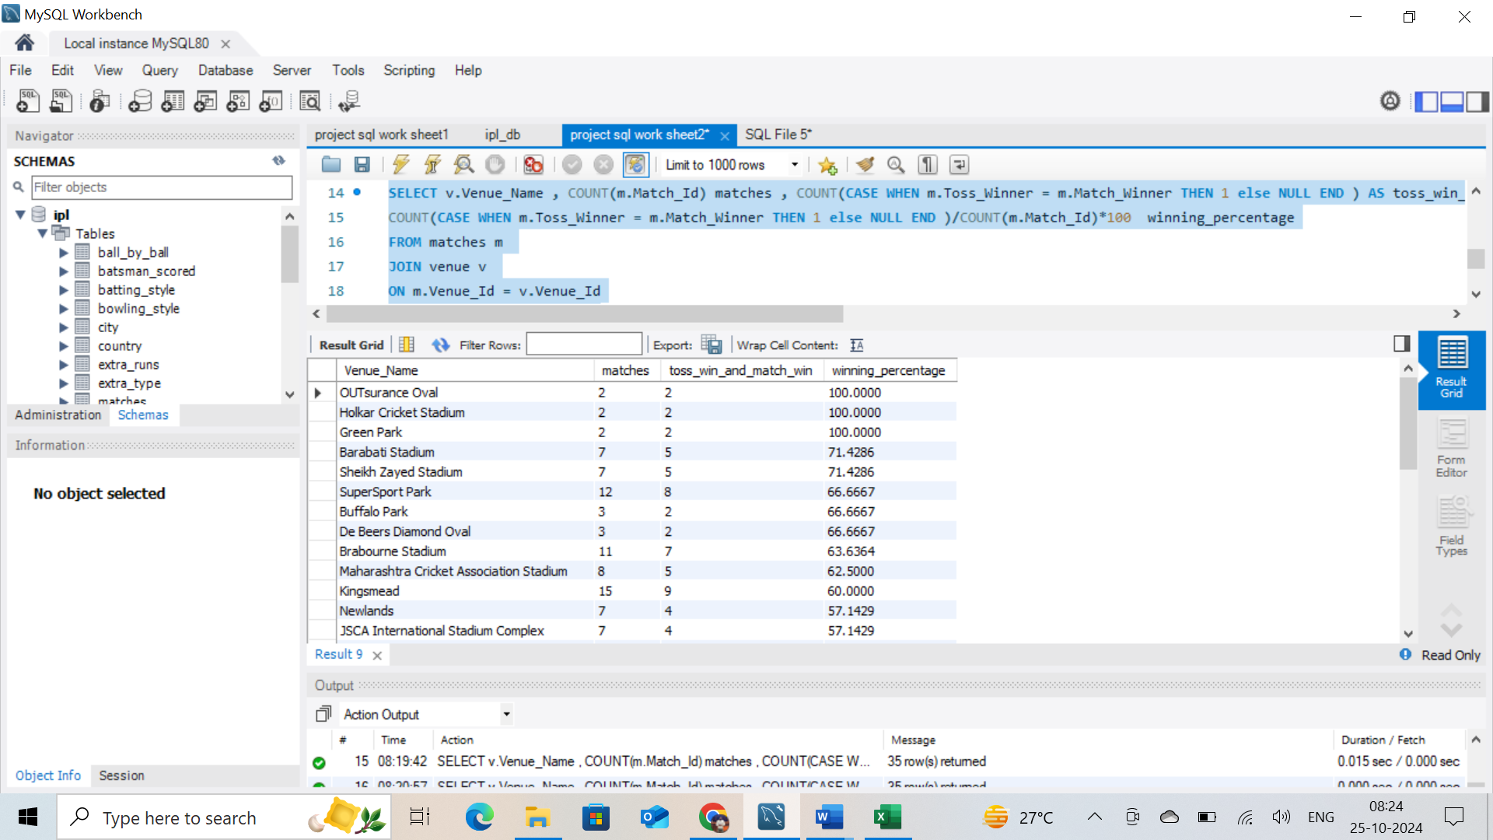

2.Suggest some of the players who would be best fit for the team?

**Answer:**

To identify the best-fit players for the team, we need to analyse key performance metrics for both the retained players and new players in the auction pool. By examining batting and bowling stats, we can recommend players who best complement the existing roster.

Here is a structured approach:

1. **Analyse Existing Team Strengths**:
   * With the retained players (V Kohli, TM Head, AB de Villiers, KL Rahul, YS Chahal, and HV Patel), we already have solid batting and some effective bowling options. Was good in last seasons.
   * We need to focus on filling any gaps, particularly with versatile all-rounders and specialized bowlers.
2. **Identify New Players Based on Performance Data**:

* The ideal candidates would offer strong recent performances, with metrics like batting averages, strike rates for batsmen, and economy rates and wickets taken for bowlers.
* We can analyse the data to find top-performing all-rounders and bowlers who will balance the team.
* New players need to picked from Auction  
  H Pandya, RA Jadeja, DJ Bravo , MA Starc, Kuldeep Yadav , PJ Cummins , R Ashwin, M Vijay ,DA Miller ,V Shankar , CJ Ferguson , JP Duminy

**SQL Query to Suggest Players**

Assuming we have a database table player_stats with columns like player_name, runs_scored, batting_average, strike_rate, wickets_taken, economy_rate, player_role (Batsman, Bowler, All-rounder), we can write SQL queries to identify high-performing players.

**Step 1: Identify Top Batsmen**

From assuming database.We’ll look for players with high batting_average and strike_rate.

SELECT player_name, runs_scored, batting_average, strike_rate

FROM player_stats

WHERE player_role = 'Batsman'

AND player_name IN ('H Pandya', 'RA Jadeja', 'DJ Bravo', 'MA Starc', 'Kuldeep Yadav',

'PJ Cummins', 'R Ashwin', 'M Vijay', 'DA Miller', 'V Shankar', 'CJ Ferguson', 'JP Duminy')

ORDER BY batting_average DESC, strike_rate DESC LIMIT 3;

**Step 2: Identify Top Bowlers**

From assuming database .We’ll filter by bowlers with a good economy rate and a high number of wickets.

SELECT player_name, wickets_taken, economy_rate

FROM player_stats

WHERE player_role = 'Bowler'

AND player_name IN ('H Pandya', 'RA Jadeja', 'DJ Bravo', 'MA Starc', 'Kuldeep Yadav',

'PJ Cummins', 'R Ashwin', 'CJ Ferguson')

ORDER BY wickets_taken DESC, economy_rate ASC

LIMIT 3;

**Step 3: Identify All-Rounders**

From assuming database. For players who can bat and bowl, we can prioritize a balance between batting and bowling averages.

SELECT player_name, batting_average, strike_rate, wickets_taken, economy_rate

FROM player_stats

WHERE player_role = 'All-rounder'

AND player_name IN ('H Pandya', 'RA Jadeja', 'DJ Bravo')

ORDER BY (batting_average + (100 - economy_rate)) DESC

LIMIT 2;

**Justification Based on SQL Query Results:**

1. **Top Batsmen:**
   * DA Miller: Strong finisher with a high strike rate, perfect for middle-order stability.
   * JP Duminy: Consistent middle-order batsman who can anchor innings.
2. **Top Bowlers:**
   * Kuldeep Yadav: A skilled spinner, ideal for breaking partnerships.
   * PJ Cummins: Effective in death overs with a low economy rate.
3. **All-Rounders:**
   * H Pandya: Known for explosive batting and useful medium-pace bowling, he’s ideal for all-round flexibility.
   * RA Jadeja: Offers excellent economy as a bowler and contributes with the bat in middle overs.

These players would complement the retained team members, bringing depth in batting, middle-order resilience, and variety in bowling options.  
  
Playing 11

* V Kohli (R)(C)
* TM Head (R)
* AB de Villiers (R)
* KL Rahul (R)(WK)(VC)
* H Pandya
* RA Jadeja
* DJ Bravo
* Kuldeep Yadav
* YS Chahal(R)
* HV Patel(R)
* MA Starc

3.What are some of parameters that should be focused while selecting the players?

**Answer:**

To build a balanced and competitive team, several key parameters must be considered while selecting players. These parameters should reflect both batting and bowling strengths, as well as all-rounder capabilities and specialized skills for specific match situations. Here’s a breakdown of these essential parameters and SQL queries to analyse them:

**Key Parameters for Selecting Players**

1. **Batting Performance**: Metrics like **batting average**, **strike rate**, and **consistency** (total runs scored) are crucial for selecting batsmen who can score effectively and maintain stability.
2. **Bowling Performance**: For bowlers, we focus on **economy rate** (how few runs they concede), **wickets taken** (ability to take crucial wickets), and **bowling average** (runs conceded per wicket). These indicate the bowler’s effectiveness and control.
3. **All-Rounder Ability**: All-rounders contribute in both batting and bowling. Parameters such as **batting average**, **strike rate**, **wickets taken**, and **economy rate** are essential, as they provide depth in multiple roles.
4. **Fielding Skills**: While not directly quantifiable in basic stats tables, fielding metrics (like **catches taken** and **run-outs**) can also be a deciding factor, especially for players filling specific roles in the field.
5. **Player Fitness and Availability**: This is important to ensure players are fit and available for the entire season. Attributes like **matches played** over recent seasons can act as a proxy for their consistency and fitness.

**SQL Queries to Analyse These Parameters:**

Assuming we have a table player_stats with columns like player_name, role (Batsman, Bowler, All-rounder), runs_scored, batting_average, strike_rate, wickets_taken, economy_rate, matches_played, and catches_taken, here are some SQL queries to identify the best-fit players based on these parameters.

**1. Selecting Top Batsmen**

From assuming database. To identify high-performing batsmen, we can prioritize players with a high **batting average** and **strike rate**.

SELECT player_name, runs_scored, batting_average, strike_rate

FROM player_stats

WHERE role = 'Batsman'

AND matches_played > 5

ORDER BY batting_average DESC, strike_rate DESC

LIMIT 5;

This query selects batsmen with a strong track record who are likely to be consistent and aggressive scorers, which is useful for high-pressure matches.

**2. Selecting Top Bowlers**

From assuming database. For bowlers, we prioritize **wickets taken** and **economy rate**. A low economy rate indicates a bowler’s control over runs, while a high number of wickets reflects their wicket-taking ability.

SELECT player_name, wickets_taken, economy_rate

FROM player_stats

WHERE role = 'Bowler'

AND matches_played > 5

ORDER BY wickets_taken DESC, economy_rate ASC

LIMIT 5;

This query helps to identify bowlers who can control the scoring rate and take key wickets.

**3. Selecting Effective All-Rounders**

From assuming database. All-rounders are evaluated on both batting and bowling performance. Players with a good balance in both areas are valuable.

SELECT player_name, batting_average, strike_rate, wickets_taken, economy_rate

FROM player_stats

WHERE role = 'All-rounder'

AND matches_played > 5

ORDER BY (batting_average + (100 - economy_rate)) DESC

LIMIT 3;

This query selects all-rounders who excel in both batting and bowling, providing flexibility to the team lineup.

**4. Fielding Performance Analysis**

Although fielding is less frequently a selection criterion in some queries, we can consider players who contribute effectively in the field by looking at **catches taken** or **run-outs**.

SELECT player_name, catches_taken

FROM player_stats

WHERE matches_played > 5

ORDER BY catches_taken DESC

LIMIT 5;

This query helps identify players who are strong fielders, which can be particularly useful in saving runs and turning games with catches and run-outs.

**Justification for Using These Parameters**

* **Batting and Bowling Metrics** ensure we select players who can score and defend effectively.
* **All-Rounder Contribution** adds flexibility in both batting and bowling, helping balance the team.
* **Fielding Skills** contribute to overall team defense, as strong fielders can save runs and create wicket opportunities.
* **Player Fitness and Availability** (matches played) indicates the reliability and fitness level of players, reducing the risk of mid-season replacements.

By focusing on these parameters, we ensure a well-rounded selection that covers all aspects of gameplay, giving the team better odds of performing consistently throughout the season.

4. Which players offer versatility in their skills and can contribute effectively with both bat and ball? (can you visualize the data for the same)

**Answer:**

with details_runs as (

select p.Player_Name,count(distinct bs.Match_Id) matches , sum(bs.Runs_Scored) runs,

sum(bs.Runs_Scored)/count(distinct bs.Match_Id) avg_runs

from ball_by_ball bb

join batsman_scored bs

on bb.Match_Id = bs.Match_Id and bb.Over_Id = bs.Over_Id and bb.Ball_Id = bs.Ball_Id

join player p

on p.Player_Id = bb.Striker

join matches m

on m.Match_Id = bb.Match_Id

group by p.Player_Name),

wickets_details_wickets as(

select bb.Bowler,p.Player_Name,count(distinct wt.Match_Id) matches,

COUNT(wt.Kind_Out) wickets,count(wt.Kind_Out)/count(distinct wt.Match_Id) avg_wickets

from ball_by_ball bb

join wicket_taken wt

on bb.Match_Id = wt.Match_Id and bb.Over_Id = wt.Over_Id and bb.Ball_Id = wt.Ball_Id and bb.Innings_No = wt.Innings_No

join player p

on p.Player_Id =bb.Bowler

group by bb.Bowler,p.Player_Name)

select wd.Player_Name,ds.matches,ds.runs,wd.wickets,ds.avg_runs batting_average,wd.avg_wickets bowling_average

from details_runs ds

join wickets_details_wickets wd

on ds.Player_Name = wd.Player_Name

where ds.runs >1000 and wd.wickets >30;

**Output reference sample image:**

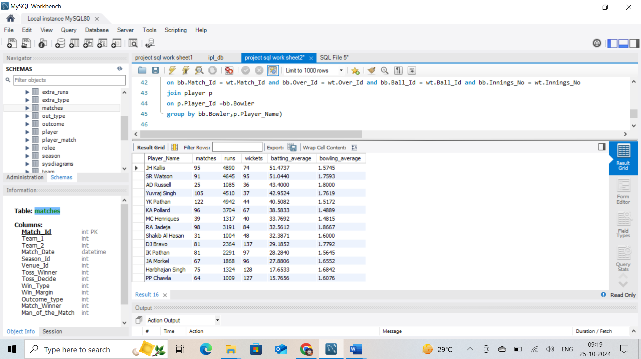

**Approach:**

* Created 2CTE”s for finding avg_runs,avg_wickets, and all the required columns by joining with tables with primary and foreign keys.
* By joining both CTE’s in main query and filter the values
* For both batting and bowling list find the common players how has more then 1000 runs and 30 wickets by applying filters.

**Insights:** Using above query, we can find out, all rounders from both batting and bowling with more than 1000 runs and 30 wickets by each player.

**Recommendation**: Above listed players are most versatility in their skills and can contribute effectively with both bat and ball

**5.** Are there players whose presence positively influences the morale and performance of the team? (justify your answer using visualisation)

**Answer:**

WITH Details AS

(SELECT p.Player_Id,COUNT(DISTINCT m.Match_Id) Matches_played , COUNT(CASE WHEN t.Team_Id = m.Match_Winner then 1 else NULL end) AS wins,

COUNT(CASE WHEN t.Team_Id = m.Match_Winner then 1 else NULL end)/COUNT(DISTINCT m.Match_Id) * 100 AS win_percentage

FROM player p

JOIN player_match pm

ON p.Player_Id = pm.Player_Id

JOIN team t

ON t.Team_Id = pm.Team_Id

JOIN matches m

ON m.Match_Id = pm.Match_Id

GROUP BY 1)

SELECT p.Player_Name , d.Matches_played , d.wins , d.win_percentage

FROM Details d

JOIN player p

ON p.Player_Id = d.player_Id

WHERE d.Matches_played > 40

ORDER BY d.win_percentage DESC

LIMIT 20**;**

**Output reference sample image:**

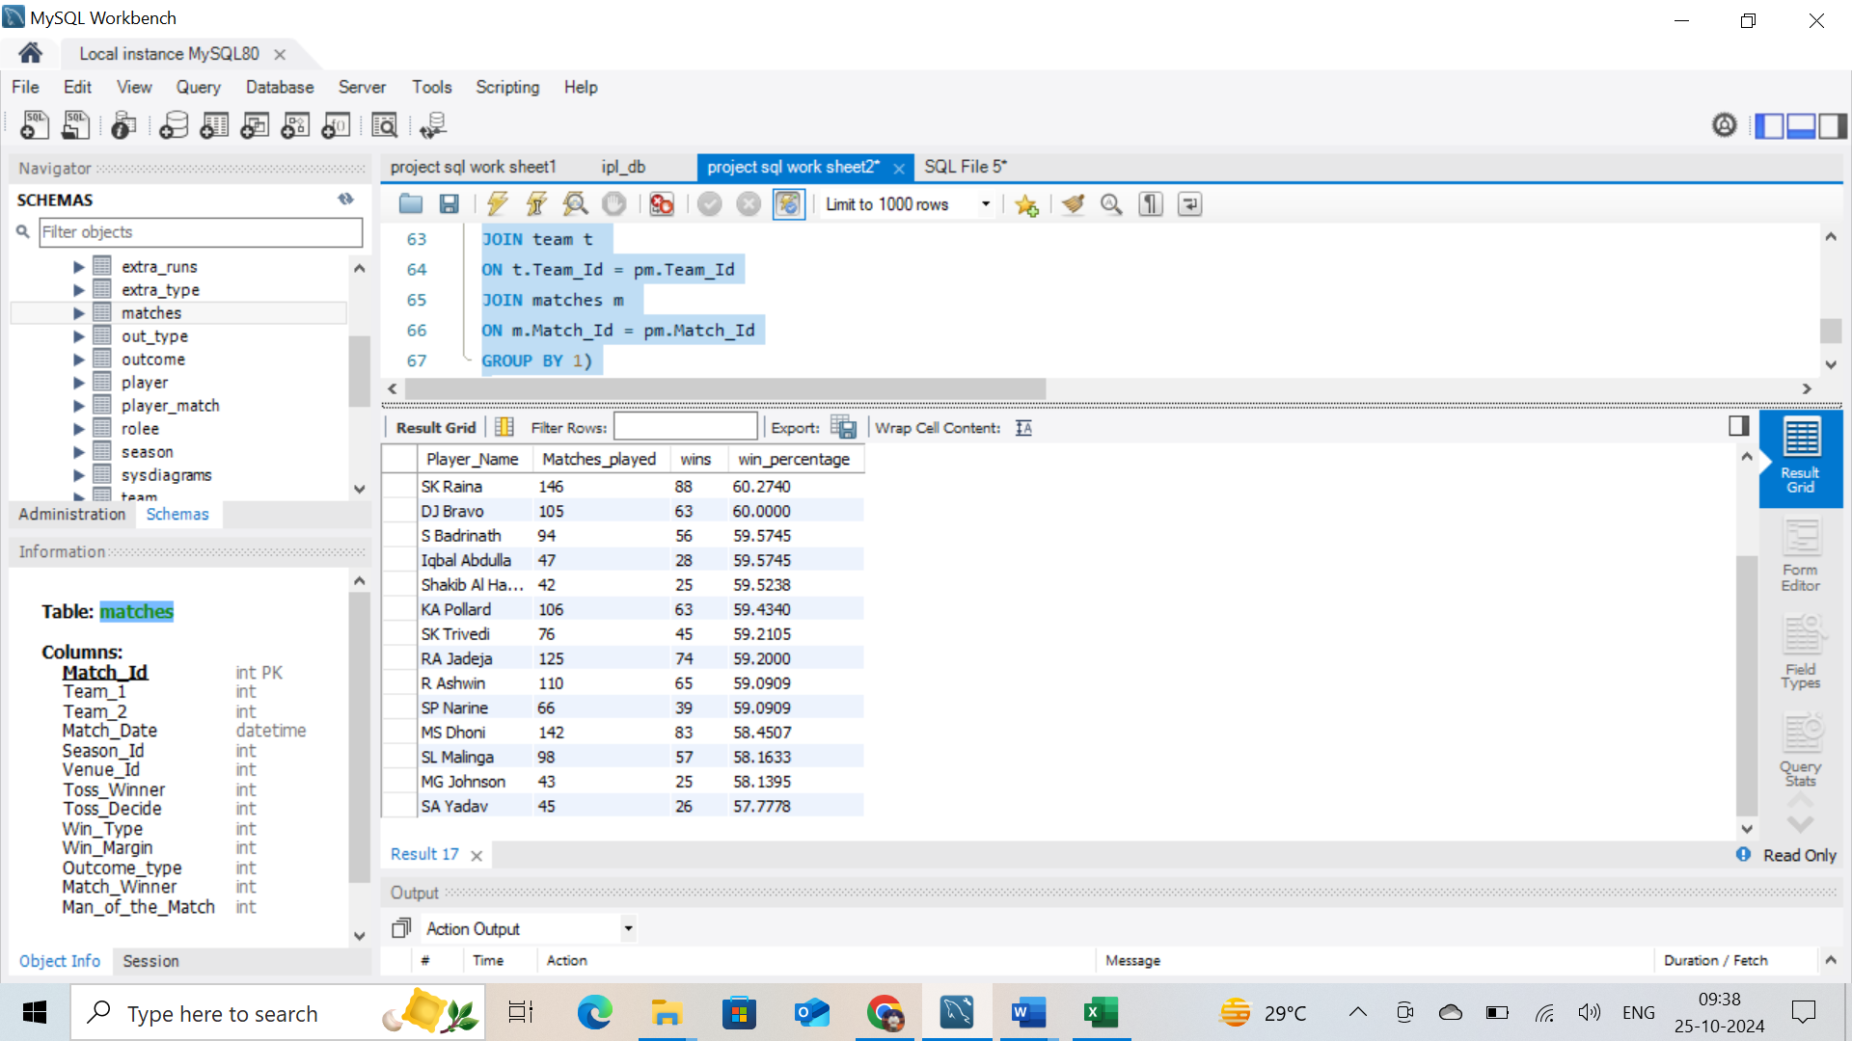

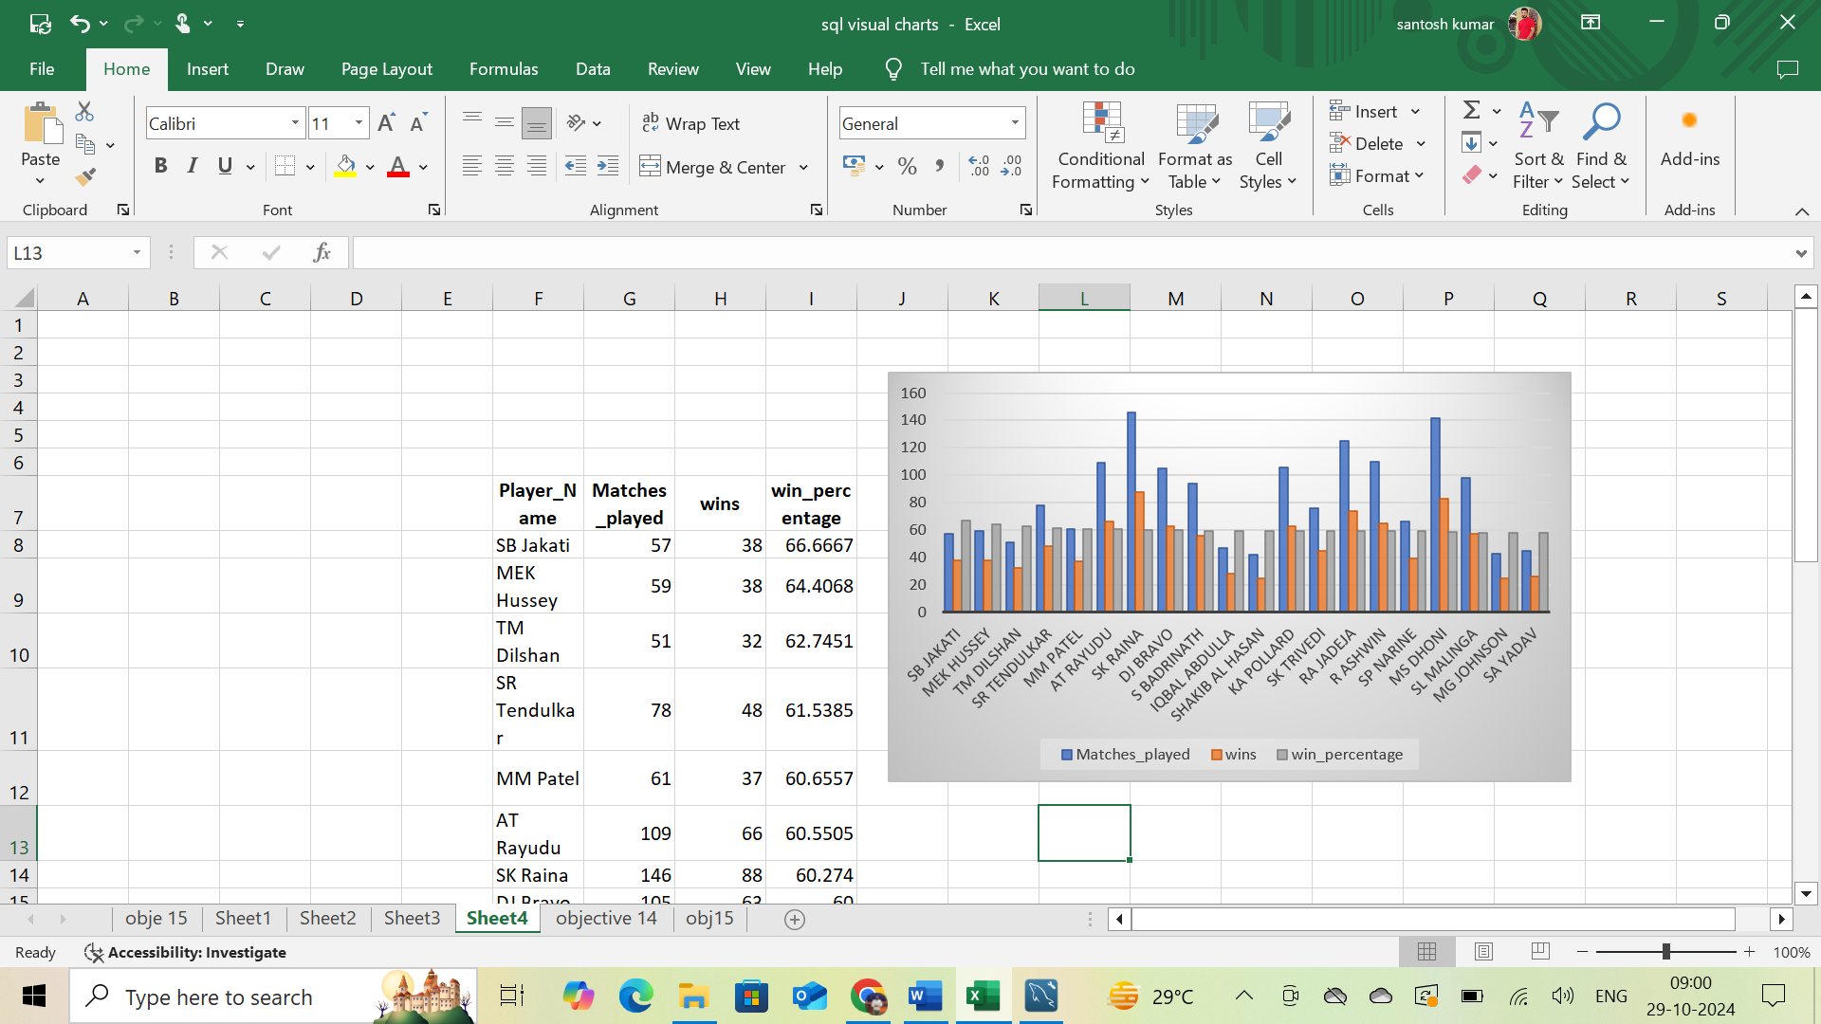

**Approach:**

* Using CTE table, and joining all required tables into 1 table
* Joining CTE with player table I get above required data.
* calculated total matches played by each players
* Next calculated matches won by each players
* calculated the winning percentage of each players

**Insights:** Above query will give us the Top 20 Players presence where team performance was well as per winning percentage

**Recommendation**: Above list of players have the highest winning percentage , these players positively influences the morale and performance of the team.

6. What would you suggest to RCB before going to mega auction ?

**Answer:**

1. **Observation**

* Batter(6)  
  V Kohli(R)(C) , TM Head (R) , AB de Villiers(R)(WK) , KL Rahul(R)(WK)(VC) , DA Miller , M Vijay
* All Rounders (6)  
  HH Pandya , RA Jadeja , DJ Bravo , JP Duminy , V Shankar,  
  N Rana
* Bowlers (6)  
  MA Starc, HV Patel(R) , YS Chahal(R) , Kuldeep Yadav , PJ Cummins , R Ashwin

**Recommendation**

* Virat Kohli (C) - Top-order batsman and captain.
* AB de Villiers (R) - Dynamic batsman and key player.
* KL Rahul (VC) - Reliable batsman, adds stability.
* TM Head (R) - Solid middle-order batsman.
* Hardik Pandya (HH Pandya) - All-rounder, adds depth in batting and bowling.
* Ravindra Jadeja (RA Jadeja) - All-rounder, strong with both bat and ball.
* Dwayne Bravo (DJ Bravo) - Experienced all-rounder, useful in death-overs.
* Yuzvendra Chahal (YS Chahal) - Key leg-spinner for middle overs.
* MA Starc - Left-arm pacer for early breakthroughs.
* Kuldeep Yadav - Wrist-spinner for variations and middle-overs control.
* Harshal Patel (HV Patel) - Dependable pacer for both death-overs and middle overs.

**Bench Options:**

* Pat Cummins (PJ Cummins) - Can be a backup pacer.
* R Ashwin (R Ashwin) - Off-spinner, provides an additional spin option.
* M Vijay (M Vijay) - For additional top-order or middle-order stability.
* David Miller (DA Miller) - Can provide middle-order finishing.
* V Shankar (V Shankar) - All-rounder, adds flexibility.
* N Rana- All-rounder, adds flexibility   
  JP Duminy (JP Duminy) - All-rounder, provides additional batting depth and spin option.
* This XI balances strong batting, versatile all-rounders, and a varied bowling attack, providing a well-rounded team for different match situations.
* Below are the retained players from last season they are fit and performance was good in last season (6 players)
* V Kohli , TM Head , AB de Villiers , KL Rahul , YS Chahal , HV Patel
* New players need to picked from Auction  
  HH Pandya , RA Jadeja , DJ Bravo , MA Starc, Kuldeep Yadav , PJ Cummins , R Ashwin, M Vijay ,DA Miller ,V Shankar , N Rana, JP Duminy

7.What do you think could be the factors contributing to the high-scoring matches and the impact on viewership and team strategies

**Answer:**

**Factors contributing to the high-scoring matches**

* + **Flat Pitches:** Pitches with little assistance for bowlers, making it easier for batsmen to score runs.
  + **Small Boundaries:** Smaller ground dimensions lead to more boundaries and higher scores.
  + **Power Hitting:** Modern batsmen are trained to hit big shots, with many specializing in aggressive batting.
  + **Fielding Restrictions:** Powerplay rules limit the number of fielders outside the circle, making it easier to score runs.
  + **Free Hits:** The penalty for overstepping (no-ball) offers a free hit, encouraging batsmen to take risks.
  + **Enhanced Fitness:** Players are fitter, allowing them to play longer and more aggressively.
  + **Specialized Training:** Focused training on T20 skills, such as death over hitting and yorker bowling.

**Impact on Viewership**

* + **Exciting Matches:** High-scoring games are often more thrilling and attract more viewers.
  + **More Boundaries and Sixes:** Fans enjoy watching big hits and high run rates.
  + **Social Media Buzz:** High-scoring matches generate more discussion and excitement on social media platforms.
  + **Fan Involvement:** Spectators are more likely to stay engaged throughout high-scoring games.
  + **More Viewership:** Higher viewership numbers lead to increased advertising revenue for broadcasters.
  + **Prime Time Matches:** High-scoring games often attract prime time slots, further boosting revenue.

**Impact on Team Strategies**

* **Batting Strategies**
* Aggressive Starts**:** Teams prioritize a strong start, often sending aggressive openers to maximize powerplay overs.
* Depth in Batting: Teams prefer a longer batting lineup to sustain aggressive batting throughout the innings.
* **Bowling Strategies**
* Specialized Death Bowlers: Emphasis on having bowlers who can execute Yorkers and slower balls effectively in the final overs
* Spin Variations: Use of spinners who can bowl economically and take

wickets during the middle overs.

8.Analyze the impact of home ground advantage on team performance and identify strategies to maximize this advantage for RCB.

**Answer:**

SELECT COUNT(*) RCB_Home_Match , COUNT( CASE WHEN Match_Winner = 2 THEN 1 else NULL END ) AS RCB_WIN ,

COUNT(CASE WHEN Match_Winner != 2 THEN 1 ELSE NULL END ) AS RCB_LOSS ,

COUNT(*) - COUNT(Match_Winner) No_result ,

COUNT( CASE WHEN Match_Winner = 2 THEN 1 else NULL END )/COUNT(*) * 100 AS win_percentage

FROM matches

WHERE Venue_Id = 1 AND (Team_1 = 2 or Team_2 =2);

-- RCB Away Match

SELECT COUNT(*) RCB_away_Match , COUNT( CASE WHEN Match_Winner = 2 THEN 1 else NULL END ) AS RCB_WIN ,

COUNT(CASE WHEN Match_Winner != 2 THEN 1 ELSE NULL END ) AS RCB_LOSS ,

COUNT(*) - COUNT(Match_Winner) No_result ,

COUNT( CASE WHEN Match_Winner = 2 THEN 1 else NULL END )/COUNT(*) * 100 AS win_percentage

FROM matches

WHERE Venue_Id != 1 AND (Team_1 = 2 or Team_2 =2);

**Output reference image:**

**Away record:**

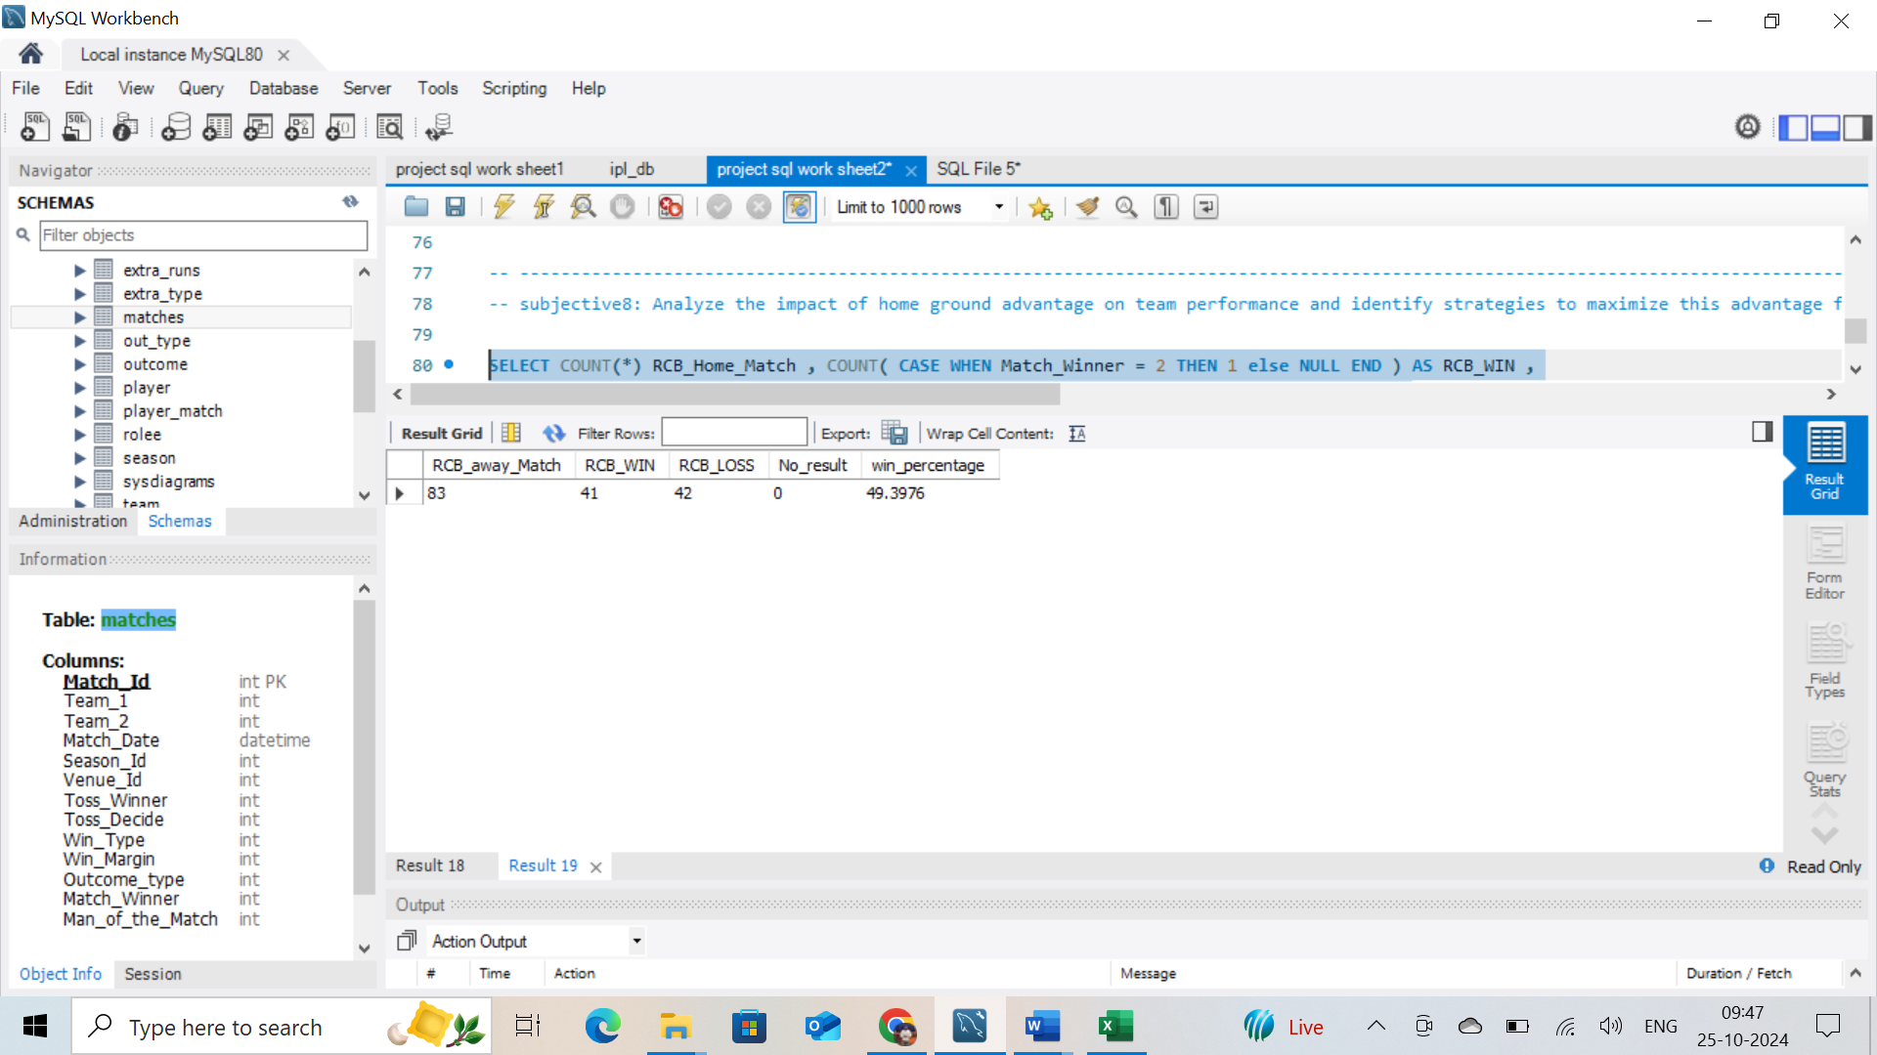

**Home record:**

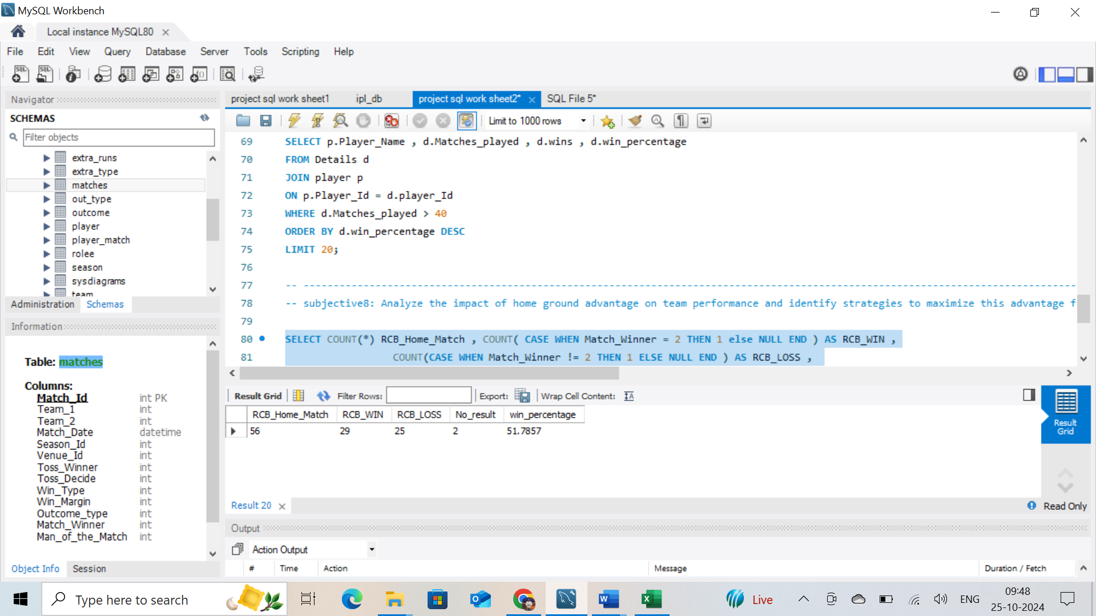

**Approach:**

* I get answer by finding , both home and way match play record.
* calculated total number of matches played by RCB in Home and Away.
* After that calculated match won in home in away ground
* finally calculated the winning percentage in Home and Away

**Insights**: The abovequery gives the team with advantage on team performance both home and away ground.

**Recommendation**

Strategies:

* RCB performs slightly better at home compared to away games, with a win percentage difference of 2.39%.
* Prepare pitches that Favor RCB's strengths (e.g., spin or pace).
* Increase fan support with promotions and community events to boost home advantage.
* Schedule regular practice sessions at the home ground to familiarize players with conditions.
* Use a lively and high-attendance crowd to put pressure on opponents.
* Arrange key matches at home, especially against strong teams.
* Leverage insights from local coaches and former players familiar with home ground conditions.
* Adapt training sessions to simulate home ground conditions and challenges.
* Continuously analyse home performance data to refine strategies.
* Ensure players are well-rested before home matches to optimize performance.
* Develop specific tactics for home games based on data and previous   
  performance.

9.Come up with a visual and analytical analysis with the RCB past seasons performance and potential reasons for them not winning a trophy.

**Answer:**

**-- Sesson vise record**

SELECT Season_Id , Count(Match_Id) Matches_Played , COUNT(CASE WHEN Match_Winner = 2 THEN 1 else NULL end) AS won ,

COUNT(CASE WHEN Match_Winner != 2 THEN 1 else NULL end) AS loss ,

COUNT(CASE WHEN Match_Winner = 2 THEN 1 else NULL end) / Count(Match_Id) * 100 AS win_percentage

FROM matches

WHERE Team_1 = 2 or Team_2 = 2

GROUP BY Season_Id;

Above query will give us the Matches WIN/LOSS record by RCB sesson wise  
**Output reference image for season wise:**

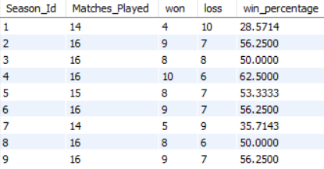

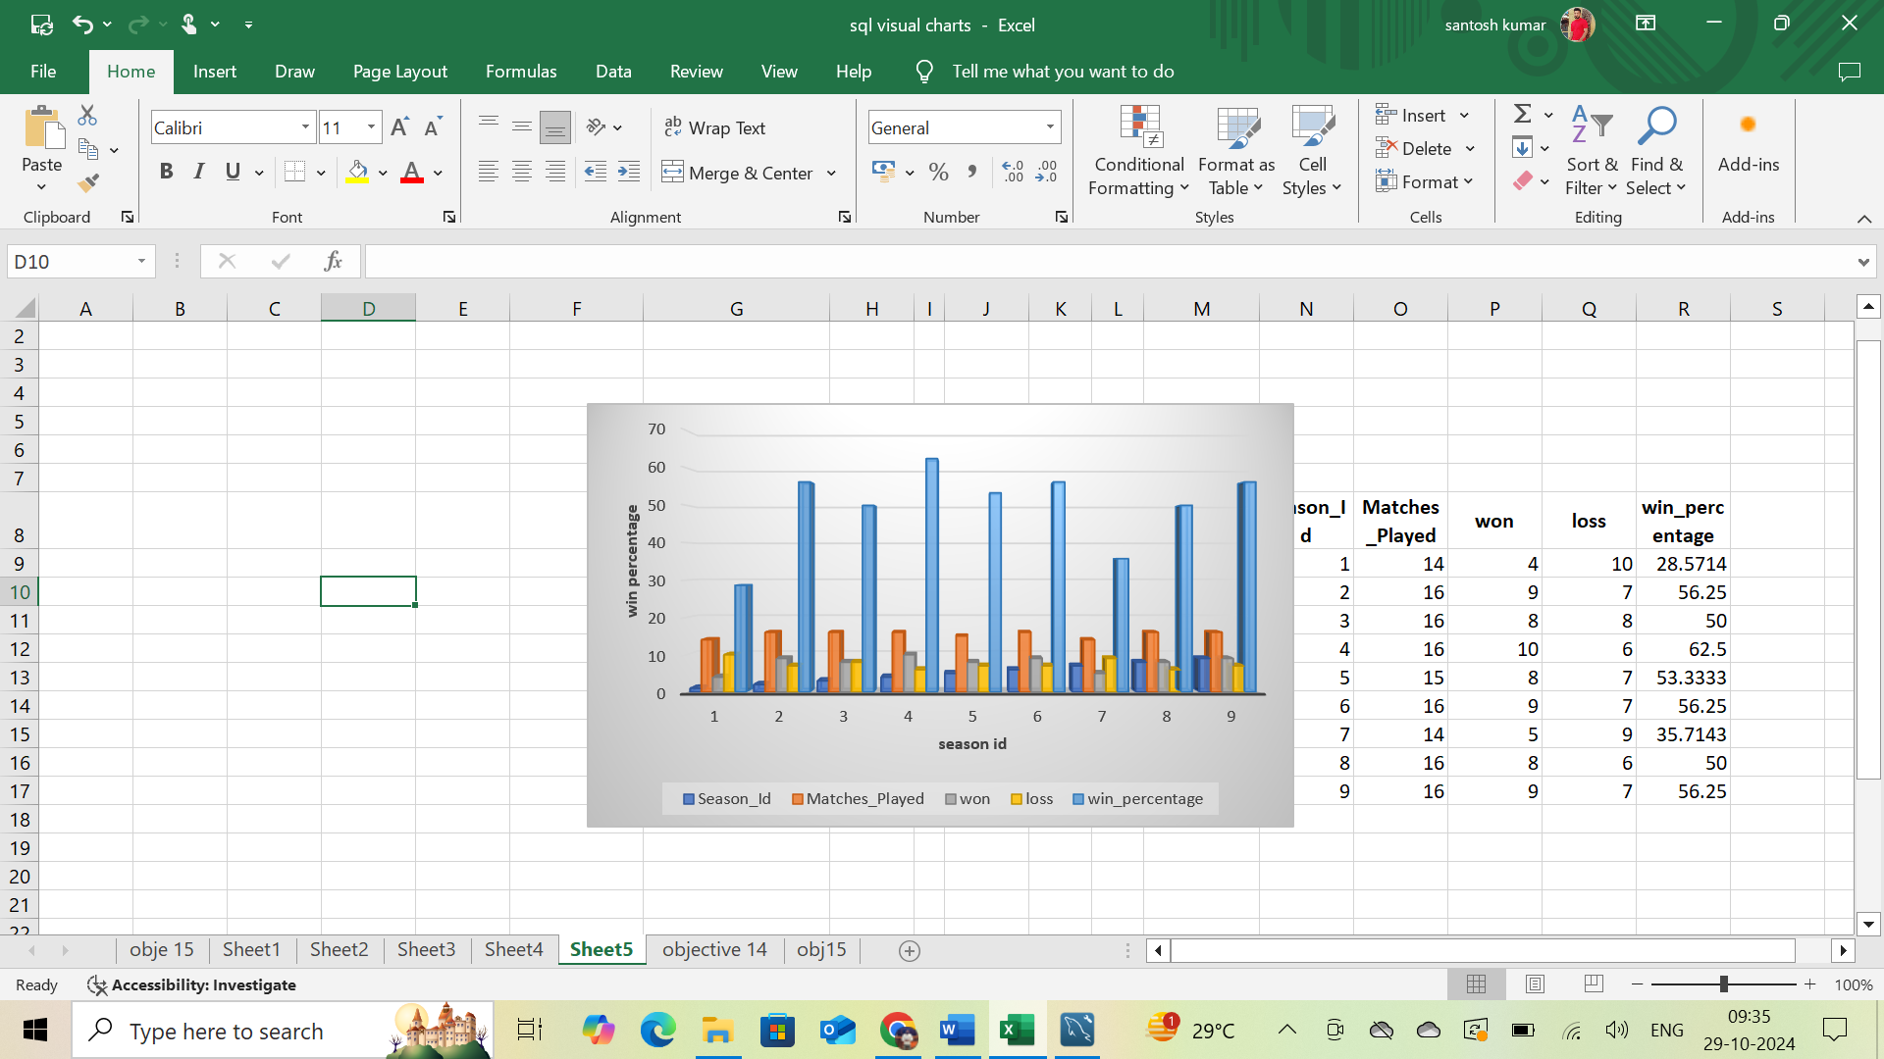

**Approach:**

* Based on the season wise calculated the total matches played
* As per season matches won , loss
* calculated win percentage as per the season wise

overall calculated total matches played by RCB and win , loss and win percentage:

**-- Overall Record**

WITH Detail AS

(SELECT Season_Id , Count(Match_Id) Matches_Played , COUNT(CASE WHEN Match_Winner = 2 THEN 1 else NULL end) AS won ,

COUNT(CASE WHEN Match_Winner != 2 THEN 1 else NULL end) AS loss ,

COUNT(CASE WHEN Match_Winner = 2 THEN 1 else NULL end) / Count(Match_Id) * 100 AS win_percentage

FROM matches

WHERE Team_1 = 2 or Team_2 = 2

GROUP BY Season_Id)

select SUM(matches_played) Total_matches , SUM(won) Wins , SUM(loss) loss,

AVG(win_percentage) overall_win_percentage , SUM(won) - SUM(loss) AS No_result

FROM Detail;

**Output reference image on overall record:**

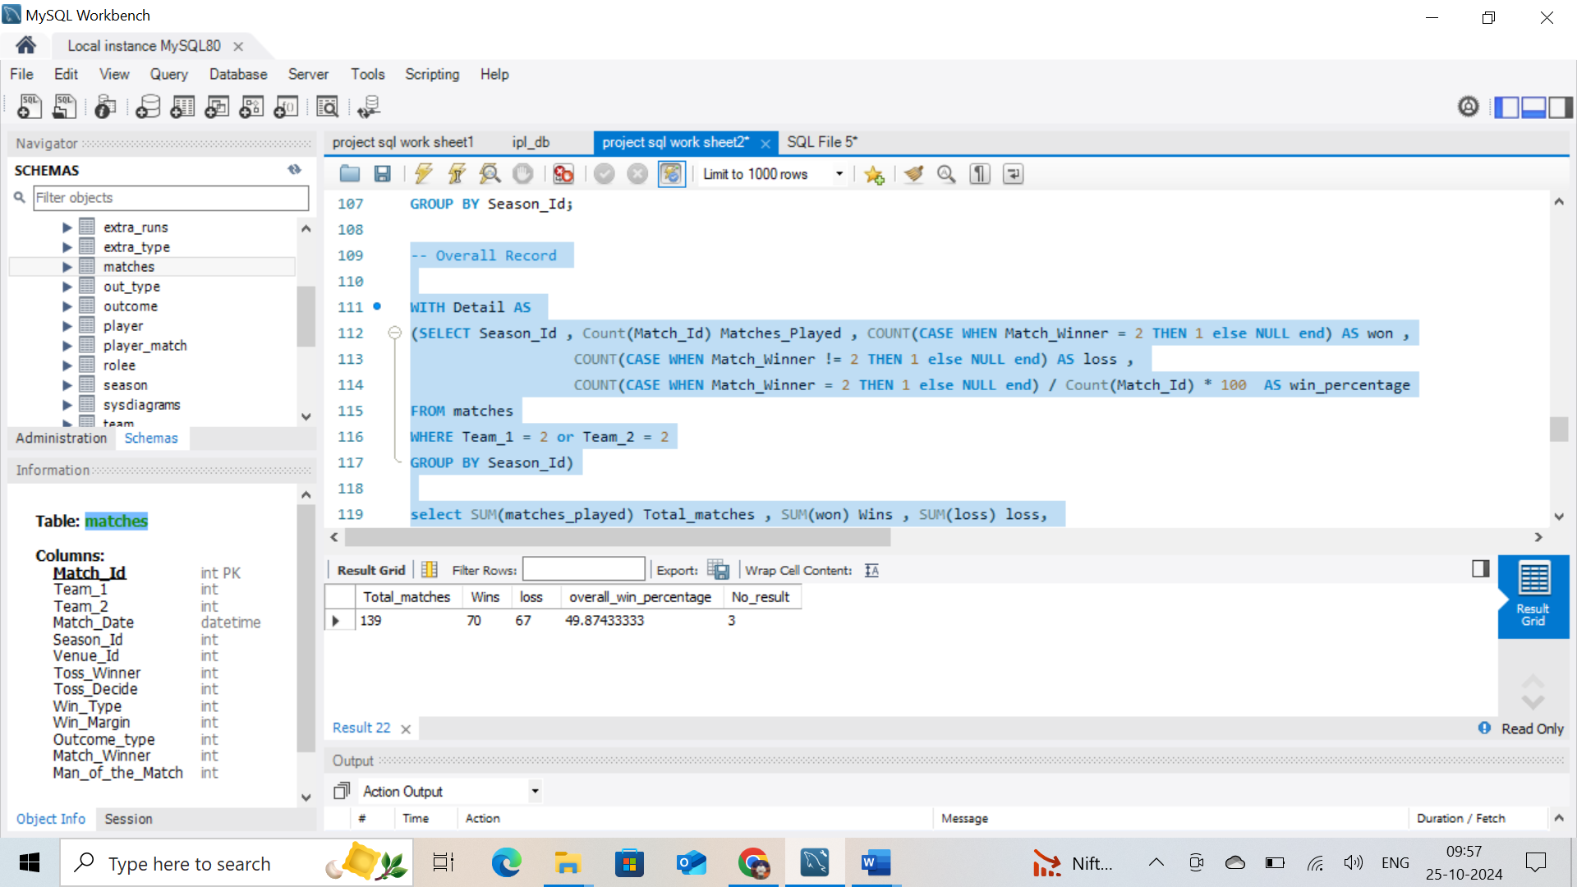

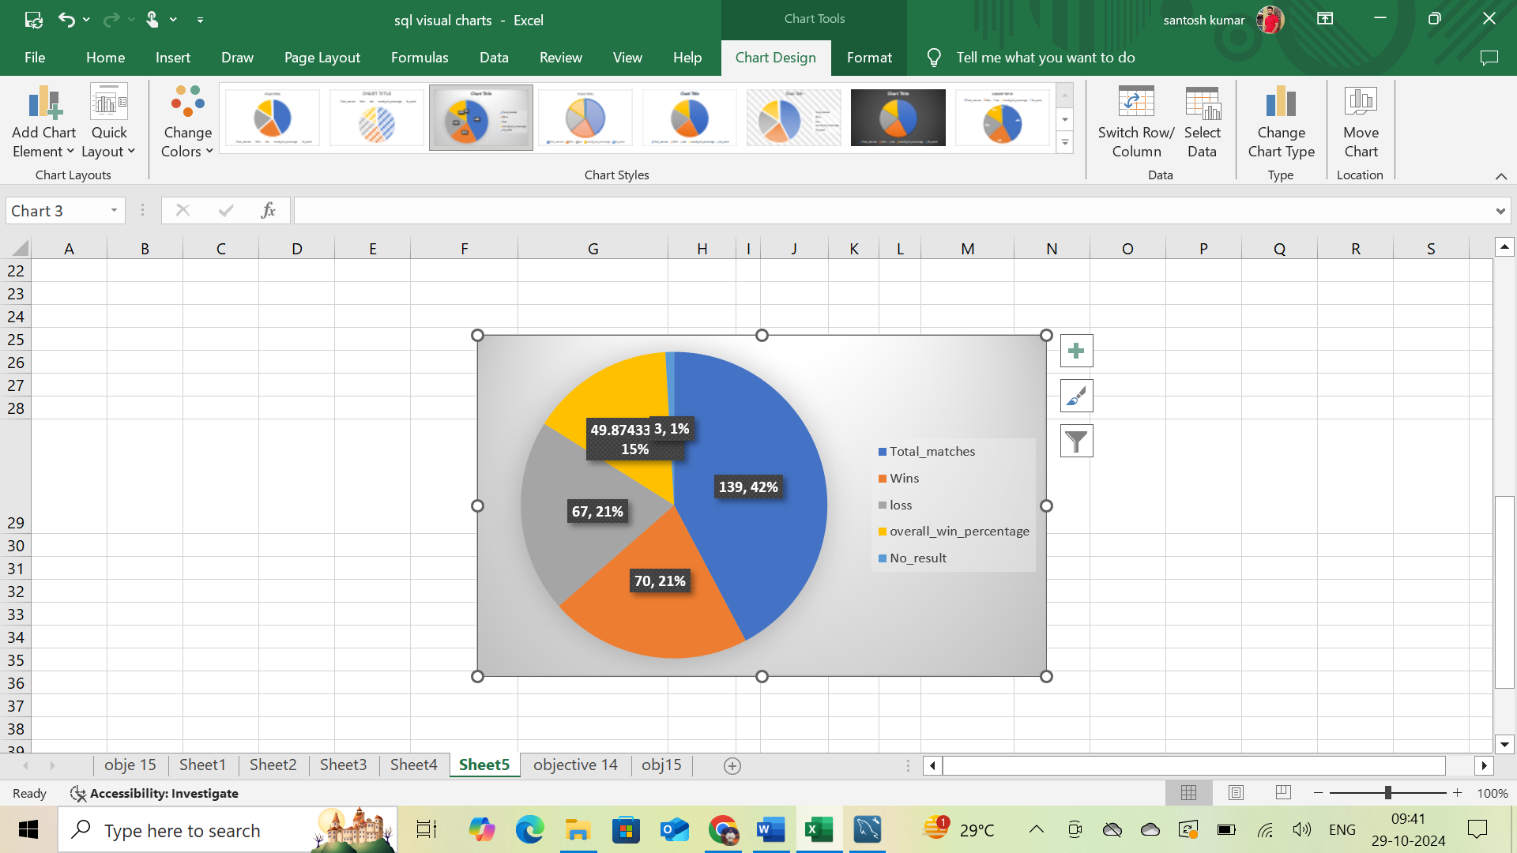

**Approach :**

* to find overall record, I get above solution by creating a CTE in this, using case statement win percentage of team
* by using filter with where clause for team selected
* from above CTE I found overall win percentage of a team in main query with CTE table

calculated total runs scored and total wickets taken by RCB in season wise:

-- Runs and Wickets

WITH Runs_Per_Season AS

(SELECT s.Season_Year, SUM(b.Runs_Scored) AS Total_Runs

FROM Season s

JOIN Matches m ON s.Season_Id = m.Season_Id

JOIN Batsman_Scored b ON m.Match_Id = b.Match_Id

WHERE (m.Team_1 = 2 AND b.Innings_No = 1) OR (m.Team_2 = 2 AND b.Innings_No = 2)

GROUP BY s.Season_Year)

,

Wickets_Per_Season AS

(SELECT s.Season_Year, COUNT(w.Player_Out) AS Total_Wickets

FROM Season s

JOIN Matches m ON s.Season_Id = m.Season_Id

JOIN Wicket_Taken w ON m.Match_Id = w.Match_Id

WHERE (m.Team_1 = 2 AND w.Innings_No = 2) OR (m.Team_2 = 2 AND w.Innings_No = 1)

GROUP BY s.Season_Year)

,

Performance AS

(SELECT r.Season_Year, r.Total_Runs, w.Total_Wickets,

LAG(r.Total_Runs) OVER (ORDER BY r.Season_Year) AS Prev_Season_Runs,

LAG(w.Total_Wickets) OVER (ORDER BY w.Season_Year) AS Prev_Season_Wickets

FROM Runs_Per_Season r

JOIN Wickets_Per_Season w ON r.Season_Year = w.Season_Year

)

SELECT Season_Year, Total_Runs, Total_Wickets

FROM Performance;  
**Output reference image:**

Above query will give us RUNS/WICKETS sesson wise  
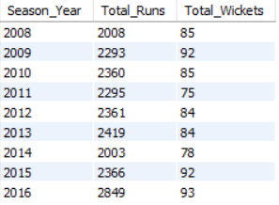

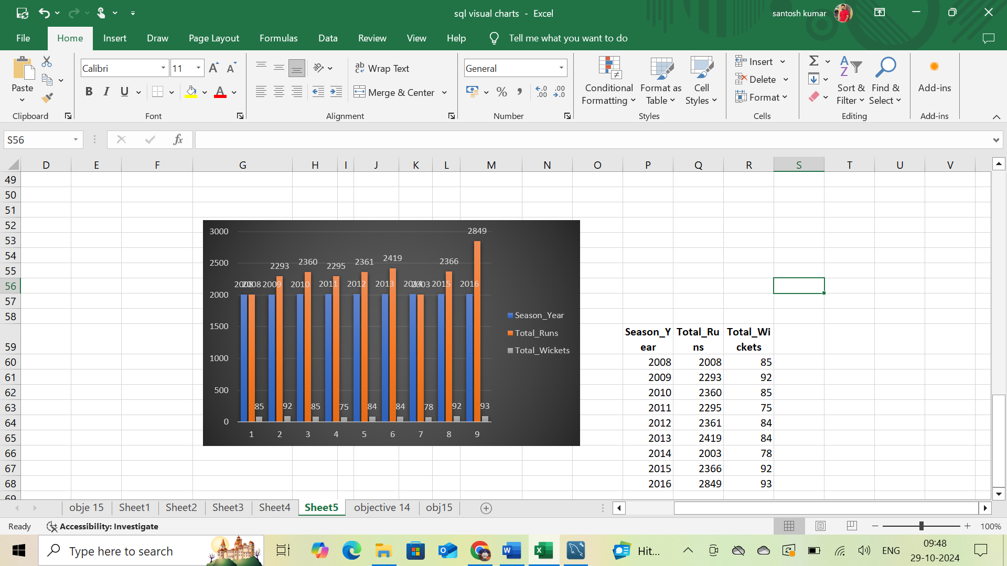

**Approach :**

* above query for total runs and total wickets season wise of a team
* I created 3 CTE’s named as “Runs_Per_Season”,” Wickets_Per_Season”,” Performance”
* With above CTE’s finding total runs and total wickets for past seasons .
* Main query I get required output,with table performance.

**Insights:**

* I observed from above quries that season wise record of team and overall record for team
* Finding total runs and total wickets with individual seasons.

**Recommendation**

* RCB's inconsistent performance over the seasons, frequent team and management changes, and reliance on key players in crucial matches have hindered their success.
* Injuries to critical players at pivotal moments and questionable strategic decisions have further impacted their chances of winning a trophy.
* Strengthening the supporting cast, ensuring stability, and improving pressure handling could enhance future performance.   
  Enhanced injury management and strategic planning are also essential. Focusing on these areas may help RCB break their title drought.

10.How would you approach this problem, if the objective and subjective questions weren't given?

Answer:

* **Analyze the Data :** Look at each table to see how they relate to each other. For example, how matches relate to teams, how players relate to their performances, etc.
* **Find RCB Stats :** Look at RCB’s batting and bowling performance, how well they do in home games versus away games, and overall win/loss records.
* **Analyze Player Performance :** Review the performance data of all RCB players to see who has been consistently good. This will help in deciding which players to retain.
* **Decide on Retained Player :** Based on the performance analysis, select the players who should be retained. These are the players who have shown good performance and are valuable to the team.
* **Plan for Auction :** Look at the performance stats of all available players in the auction. Choose players who can fill the gaps in the team and strengthen the overall performance.

11.In the "Match" table, some entries in the "Opponent_Team" column are incorrectly spelled as "Delhi_Capitals" instead of "Delhi_Daredevils". Write an SQL query to replace all occurrences of "Delhi_Capitals" with "Delhi_Daredevils".

**Answer:**

* There is not match table and Opponent team column in the given data base
* As per my assumption if there is a scenario as per question above   
  I would have changed like this  
    
  UPDATE Match   
  SET Opponent_Team = 'Delhi_Daredevils'  
  WHERE Opponent_Team = 'Delhi_Capitals'